FTAC Grant Report

The Anthropology program under the HAPPSS Department was awarded a FTAC grant in 2015. The Application requested money for 4 IPADS, 4 tablet Styluses, 4 GPS units, and one 10 station lockable charger/Dock for IPads. The purpose for this equipment was twofold. First, we wanted the equipment for our field school instruction. A major component of our archaeology field school is to teach students in various new technologies being used in the field. We already are fortunate to be able to give hands on instruction in the Use of Total Station, LIDAR, and Drones. The IPads and accessories allowed us to teach a number of different applications in the 2015 and 2016 Summer field schools. These applications include digital data collection and data management, Photogrammetry, and digital sketching/and mapping.
Second, this equipment has continued to be utilized in other anthropology classrooms for demonstration purposes as well as the Cultural Resource Management (CRM) program run under the university that gives students paid opportunities to do CRM work in the local region for pay.
The students have accepted the new technology very well. They have learned new software in the field effectively and have also tested out various other applications to consider in the future. We determined that the pen/stylus we chose to purchase were not as useful as we hoped but we are looking at other stylus/pen solutions that may work better. The students have also developed protocols for the best way to utilize certain apps in the field and have worked together to teach their peers. We are getting great data from this technology and it has streamlined our data management and research efforts moving forward.

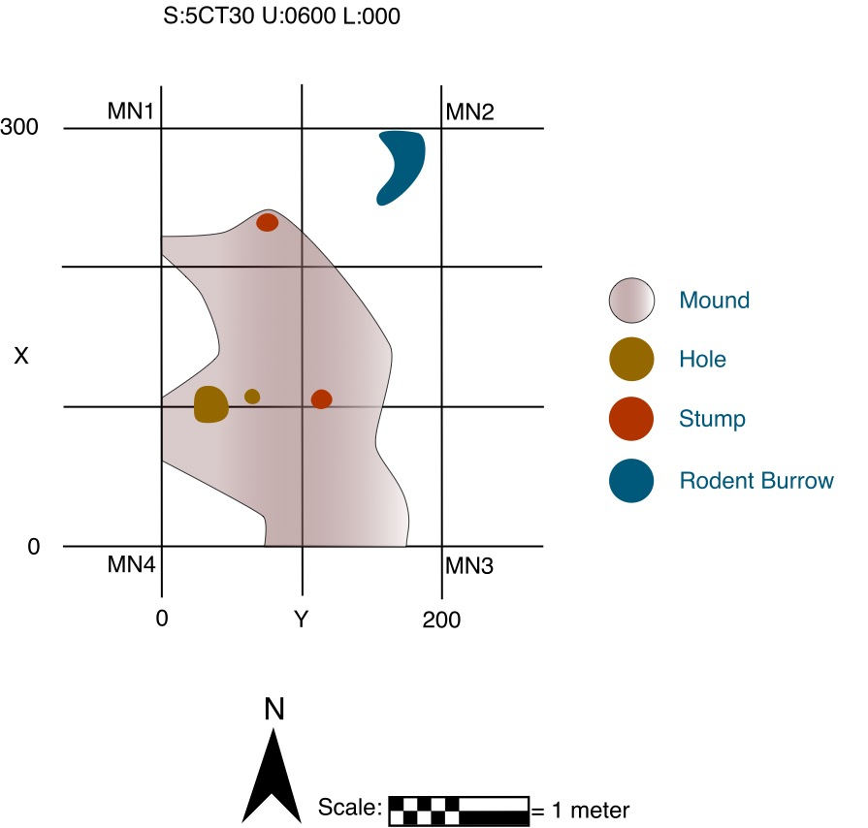

Plan view of a six square meter excavation unit drawn on Ipad.

Here are 2 soil profiles drawn on the IPads from the 2015 Field School
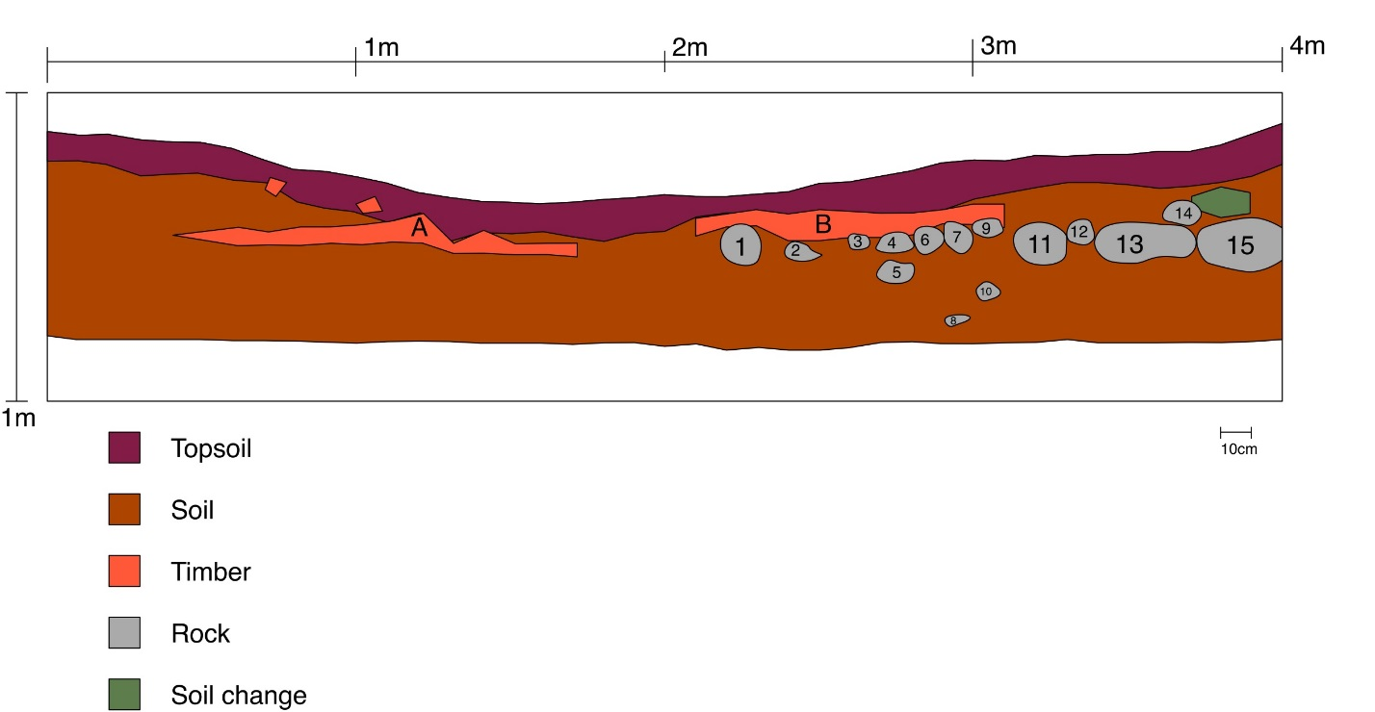

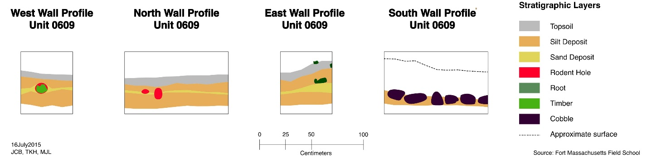

To view two 3D models of excavation units from Photogrammetry techniques built using the IPads.
Go to https://skfb.ly/Xq8t and https://skfb.ly/Xq9t.

