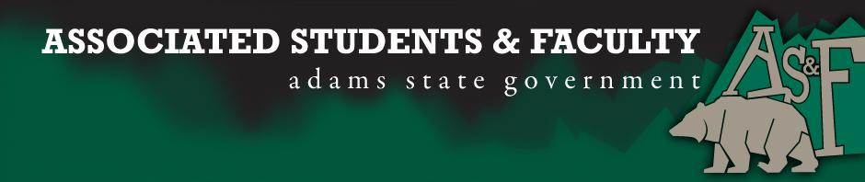

Adams State University Associated Students and Faculty Legislature
Bill Number: ASF1516026

Club Name: Veterans at Adams State
Event Name or Trip Destination: 4th Annual Veterans Banquet
Total Amount of AS&F Funding: $875.00
Total Club Points: 73
Author: Eli Jarrett
Sponsor: Morgan Fitzgibbon (Senator)

Event or Trip Information
Who: Veterans at Adams State University will be hosting the 4th annual veteran’s banquet
What: The 4th annual veteran’s banquet will be to honor all the San Luis Valley veterans and to show appreciation for the support that the Veterans at Adams State has received over the years.
Where: There are two different places we are exploring.
When: April 9th
Why: We have used funds raised at the banquet to directly support the Veterans Club with different community outreach programs that we conduct throughout the year, for example we sponsor the veterans/ upward bound mentor ship hike in the summer, veterans resource fairs, community outreach, and hosting the 2016 student veterans leadership summit.

Author Contact Information: jarretta@grizzlies.adams.edu

Account Information: 3200-876-7630-1900

Additional Information: We are requesting just the air fare and speaking fees for our guest speaker from 22 Until Valhalla.

Assessment Rubric:
What do you want people attending the event, program, or going on the trip to gain from this experience? (Required for funding requests) (Check/circle all that apply)

X· Expanding the Learning Experience
· Analytical Reasoning
· Internal Self-Development
· Improving Teamwork and Leadership
X· Community Service and Civic Engagement
· External Skill Development

Please define how your event, program, or trip will help people gain from this experience according to the goals you have checked.
Raising awareness about veteran suicide rates and relating that veterans not only at Adams State but nationwide.

I, Eli Jarrett, present this bill for consideration of and approval by the Associated Students and Faculty Senate, this 9th day of November, 2015.

Implementation: Upon approval, be it enacted that:
- The proposed bill become adopted in favor of recognition by the AS&F Senate, and that:
- Veterans at Adams State be funded $875.00

VOTE: Yeas_____ Nays______ Abs_______
Complete applicable sections:
- ADOPTED at ______________ meeting of the AS&F Senate on ___________.
- BILL did not pass at ______________ meeting of the AS&F Senate on ________.
- BILL will be reconsidered on ___________________.

Approved/Disapproved by AS&F President
_______________________________

