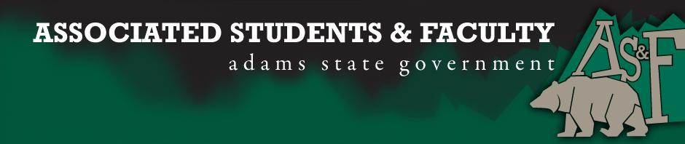

Adams State University Associated Students and Faculty Legislature
Bill Number: ASF1516012

Club Name: SACNAS
Event Name or Trip Destination: 2015 SACNAS National Conference
Total Amount of AS&F Funding: $4,199.92
Total Club Points: 83
Author: Alex Mullins
Sponsor: Dr. Nick Saenz

Event or Trip Information
Who: SACNAS Officers and active members
What: 2015 SACNAS National Conference
Where: Washington, D.C
When: October 27-31
Why: We have two presenters that will be presenting their original research. Also the SACNAS National Conference is a great place for both undergraduate and graduate students to network with professionals, mentors, students, professors and more. Over 1,000 student presentations and workshops to gather an incredible amount of experience and knowledge that can’t be found collectively anywhere else!
Author Contact Information: Phone: 719-688-6519

Account Information: 3200-873-7619-1900

Additional Information: The conference is something that must be experienced first for inspiration, and then again for networking, and finally for making contacts for graduate and medical school applications. This is why we would like to take students early in their college career and then again as they progress and refine their goals.

Assessment Rubric:
What do you want people attending the event, program, or going on the trip to gain from this experience?

· X Expanding the Learning Experience
· X Analytical Reasoning
· X Internal Self-Development
· X Improving Teamwork and Leadership
· Community Service and Civic Engagement
· X External Skill Development

Please define how your event, program, or trip will help people gain from this experience according to the goals you have checked.
(Please define only the boxes checked)
Expanding the Learning Experience- Attendees of the conference are from around the world and all walks of life. With the vast amount of knowledge being presented there is so much to learn at this conference. Presentations and seminars range in topics to fit all interests.
Analytical Reasoning: Throughout the conference scientific research and data are presented. Many ask questions and have activities that require analytical thinking/reasoning.
Internal Self-Development: This conference changes many lives and many people who do not plan on attending graduate school change their minds. Many undergraduates also return motivated to participate in undergraduate research and have returned to the conference the following year to present their research. It inspires individuals to continue with their educational career and come back better then ever.
Improving Teamwork and Leadership: Throughout the conference many groups are assigned and activities require students to participate in groups. Also many leadership seminars/talks are giving during the conference which are very inspiring and give students confidence to become future leaders or strengthen their leadership abilities.
External Skill Development: Workshops and activities are a great place to develop some external skills at the conference. Also there are many opportunities to converse with professors, mentors, and professionals alike in order to gain insight into real world job opportunities. Many talk are based around getting into graduate school and how to get jobs with specific organizations.

I, Alex Mullins present this bill for consideration of and approval by the Associated Students and Faculty Senate, this 28th day of September, 2015.

Implementation: Upon approval, be it enacted that:
- The proposed bill become adopted in favor of recognition by the AS&F Senate, and that:
- SACNAS be funded $4199.92
VOTE: Yeas_____ Nays______ Abs_______
Complete applicable sections:
- ADOPTED at ______________ meeting of the AS&F Senate on ___________.
- BILL did not pass at ______________ meeting of the AS&F Senate on ________.
- BILL will be reconsidered on ___________________.

Approved/Disapproved by AS&F President
_______________________________

