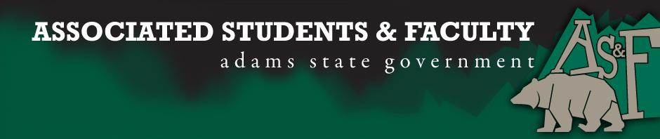

Adams State University Associated Students and Faculty Legislature
Bill Number: ASF1516013

Club Name: Psychology Club
Event Name or Trip Destination: 9/11 and Academia Conference
Total Amount of AS&F Funding: $618.94
Total Club Points: 70
Author: Kelsie Baggs
Sponsor: Psychology Club

Event or Trip Information
Who: Kelsie Baggs, Psychology Club Secretary, will be attending an Academic Psychology Conference with Dr. Demski to present their research
What: We will be presenting our research on how 9/11 has effected psychological theory, as well as clinical practice.
Where: The conference is located in Emory, Virginia
When: The conference is November 6 and 7th.
Why: our hope is to achieve funding to be able to attend the conference and make connection with other academic officials throughout the country.

Author Contact Information: Kelsie Baggs
Email: baggskd@grizzlies.adams.edu
Phone: 208-206-0856

Account Information: 3200-840-7630-1900

Additional Information: in order to receive the cheapest flight, Dr. Demski and I will be driving to Denver then flying out to Tennessee, after we land we will be driving 1.5 hours to Emory, VA. Between the flight and the gas, the traveling funds are most of the cost. My only hope is to be able to attend and retain as much information and connections made there in order to enhance the academic opportunities here on campus.

Assessment Rubric:
What do you want people attending the event, program, or going on the trip to gain from this experience? (Required for funding requests) (Check/circle all that apply)

· Expanding the Learning Experience (X)
· Analytical Reasoning
· Internal Self-Development (X)
· Improving Teamwork and Leadership (X)
· Community Service and Civic Engagement
· External Skill Development (X)

Please define how your event, program, or trip will help people gain from this experience according to the goals you have checked.

I wish to expand my own learning experience by learning from the presenters as well as attending meetings with professors and presenting my research with fellow undergrads like myself. The internal self-development will happen as I learn the process of how a conference works as well as going to workshops provided at the conference for professional development. In order to enhance my leadership skills, I am setting an example for the new members of our psychology club that has more than doubled in the last two years by showing them that if they are to do research (alone or accompanied by a professor) they may be able to attend conferences and expand their network of connections throughout the country. Lastly, my own skill development will happen with I get to practice my public speaking as well provide a poster presentation. These are excellent attributes to have when thinking about applying and attending graduate school.

I, Kelsie Baggs, present this bill for consideration of and approval by the Associated Students and Faculty Senate, this 28th day of September, 2015.

Implementation: Upon approval, be it enacted that:
- The proposed bill become adopted in favor of recognition by the AS&F Senate, and that:
- Kelsie Baggs; Psychology Club be funded $618.94

VOTE: Yeas_____ Nays______ Abs_______
Complete applicable sections:
- ADOPTED at ______________ meeting of the AS&F Senate on ___________.
- BILL did not pass at ______________ meeting of the AS&F Senate on ________.
- BILL will be reconsidered on ___________________.

Approved/Disapproved by AS&F President
_______________________________

