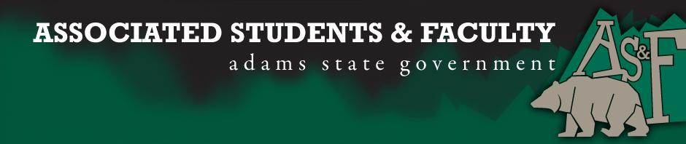

Adams State University Associated Students and Faculty Legislature
Bill Number: ASF1516020

Club Name: PBL
Event Name or Trip Destination: National Fall Leadership Conference in Baltimore MD
Total Amount of AS&F Funding: $6789.58
Total Club Points: 70
Author: Danielle Quintana
Sponsor: John Owsley (Senator)

Event or Trip Information
Who: 7 PBL Chapter members and our advisor Natalie Rogers
What: We are attending a national leadership conference where Students and advisers participate in motivational general sessions, professional development, and career planning workshops.
Where: Baltimore Maryland
When: November 19th – 22nd
Why: We hope to receive funding that will allow us to attend this conference that will not only better our members as leaders but to share our successes, and learn new ideas about shaping our career future through workshops and exhibits

Author Contact Information: asupbl@grizzlies.adams.edu

Account Information: 3200-839-7630-1900

Additional Information:

Assessment Rubric:
What do you want people attending the event, program, or going on the trip to gain from this experience? (Required for funding requests) (Check/circle all that apply)

· X Expanding the Learning Experience
· Analytical Reasoning
· X Internal Self-Development
· X Improving Teamwork and Leadership
· Community Service and Civic Engagement
· External Skill Development

Please define how your event, program, or trip will help people gain from this experience according to the goals you have checked.
Expanding the Learning Experience
Through the National Fall Leadership Conference members will learn many different skills and receive many different learning experiences that cannot be offered anywhere else. They will be able to relate the things that they are learning in their classes to the respective competitive events that they are competing in.

Improving Teamwork and Leadership
We will attend many different workshops and keynotes where we will learn different leaderships styles, practices, and tips that we can not only grow as a leader but we can bring back to the different clubs an organizations here on campus

I, Danielle Quintana, present this bill for consideration of and approval by the Associated Students and Faculty Senate, this 9th day of November, 2015.

Implementation: Upon approval, be it enacted that:
- The proposed bill become adopted in favor of recognition by the AS&F Senate, and that:
- PBL be funded $6789.58

VOTE: Yeas_____ Nays______ Abs_______
Complete applicable sections:
- ADOPTED at ______________ meeting of the AS&F Senate on ___________.
- BILL did not pass at ______________ meeting of the AS&F Senate on ________.
- BILL will be reconsidered on ___________________.

Approved/Disapproved by AS&F President
_______________________________

