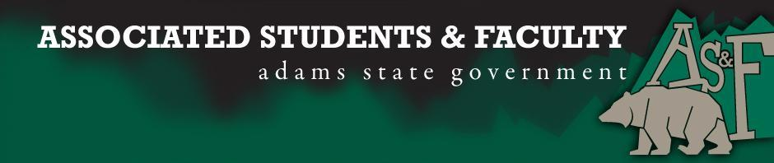

Adams State University Associated Students and Faculty Legislature
Bill Number: ASF1516011

Club Name: Model United Nations
Event Name or Trip Destination: Annual MUN conference
Total Amount of AS&F Funding: $5259.86
Total Club Points: 120
Author: Stevon Cornish, Jeremiah Medina, Nataly Acurio
Sponsor: Sean Erice

Event or Trip Information
Who: Six members of the Model UN team and our advisor, Dr. Centeno, hope to attend a Model United Nations Conference. While representing ASU, the MUN team travels abroad to participate in an annual conference, often as the only group from the United States. Most recently, in the spring of 2015, our team won three awards at the MEDMUN conference, against Ivy League and European universities.

What: ScotMUN 2016

Where: Edinburgh, Scotland

When: (March 2nd – March 12th)

Why: MUN is requesting funding to assist in payment of travel expenses (mileage and airfare)

Author Contact Information: Stevon Cornish cornishs@grizzlies.adams.edu, Jeremiah Medina medinaja1@grizzlies.adams.edu and Nataly Acurio acurion@grizzlies.adams.edu

Account Information: 3200-864-7630-1900

Additional Information:

Assessment Rubric:
What do you want people attending the event, program, or going on the trip to gain from this experience? (Required for funding requests) (Check/circle all that apply)

· Expanding the Learning Experience X
· Analytical Reasoning X
· Internal Self-Development X
· Improving Teamwork and Leadership X
· Community Service and Civic Engagement
· External Skill Development X

The ASUMUN team will be collaborating and debating on a variety of different international topics while attending the upcoming MUN conference. In preparation for the conference, team members will engage in: research, discussion and debate about current, past and future global issues. Participating individuals (delegates) will each represent an assigned country’s position on the debate topics. Therefore, delegates are required to gain an in-depth knowledge of their own countries in addition to learning the positions of the other countries that will serve as allies or adversaries during debate. Conference participation also requires quick thinking and diplomacy. The Model UN team trains for several hours a week to prepare all of the skills required to succeed at these international competitions. The weekly trainings promote teamwork, while the competitions themselves allow for both individual and team success. Beyond competition, delegates have the opportunity to hear from former world leaders and current diplomats and international scholars, who often come to speak at MUN conferences. Delegates often come from different countries in real life, and share experiences during breaks and committee dinners. Social Media networking among delegates continues for years after conferences end. Moreover, the fact that the conference is in another country requires the Adams State Team to prepare in terms of basic cultural literacy before we leave the U.S. and to gain a culturally, socially, historically (often politically and economically) enriching experience. The ASUMUN member develops a global perspective while giving part of the globe a positive perspective of ASU.

We, Stevon Cornish, Jeremiah Medina, and Nataly Acurio present this bill for consideration of and approval by the Associated Students and Faculty Senate, this 28th day of September, 2015.

Implementation: Upon approval, be it enacted that:
- The proposed bill become adopted in favor of recognition by the AS&F Senate, and that:
- MUN be funded $5259.86

VOTE: Yeas_____ Nays______ Abs_______
Complete applicable sections:
- ADOPTED at ______________ meeting of the AS&F Senate on ___________.
- BILL did not pass at ______________ meeting of the AS&F Senate on ________.
- BILL will be reconsidered on ___________________.

Approved/Disapproved by AS&F President
_______________________________

