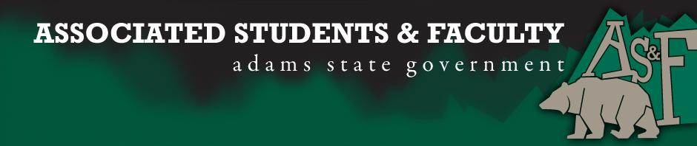

Adams State University Associated Students and Faculty Legislature
Bill Number: ASF1516015

Club Name: Adams State Student Nursing Association (ASSNA)
Event Name or Trip Destination: World AIDS Week
Total Amount of AS&F Funding: $1059.28
Total Club Points: 49
Author: Ellie Farlow
Sponsor: Brittanie Bagby

Event or Trip Information
Who: ASSNA and World AIDS Day Committee
What: World AIDS Week
Where: Adams State University
When: November 30 – December 3, 2015
Why: Bringing AIDS awareness to Adams State and the surrounding community

Author Contact Information:
Phone: 312-480-0686
Email: farloweh@grizzlies.adams.edu

Account Information:
ASSNA Account: 3200-853-7630-1900

Additional Information:
This event will take place over three to four days in November and December 2015. We will be displaying three pieces of the AIDS quilt and putting on a candle light vigil with a guest speaker to talk about AIDS and how the disease impacts families and communities. There will also be a table set up in the Student Union Building where students, faculty and members of the community can learn about getting tested for HIV and STIs, information on how to prevent the spread of HIV/AIDS and what they can do to get involved in future World AIDS Days.

Assessment Rubric:
What do you want people attending the event, program, or going on the trip to gain from this experience?

- Expanding the Learning Experience
- Analytical Reasoning
- Internal Self-Development
- Improving Teamwork and Leadership
- Community Service and Civic Engagement
- External Skill Development

The main goal of ASSNA and the World AIDS Day Committee is to bring awareness to the students, faculty, and community of Adams State University about Acquired Immune Deficiency Syndrome (AIDS). Many people believe AIDS is no longer a disease that we need to talk about and many have forgotten just how horrible and devastating an AIDS diagnosis can be. We want to educate the community on how to protect themselves from the spread of AIDS and how to get tested if they have any concerns about contracting AIDS or other sexually transmitted diseases. By starting a conversation about AIDS at Adams State University we can hopefully help or prevent anyone in our community from contracting or spreading the disease.

I, Elliott Farlow, present this bill for consideration of and approval by the Associated Students and Faculty Senate, this 28 day of September, 2015.

Implementation: Upon approval, be it enacted that:
- The proposed bill become adopted in favor of recognition by the AS&F Senate, and that:
- ASSNA be funded $1059.28

VOTE: Yeas_____ Nays______ Abs_______
Complete applicable sections:
- ADOPTED at ______________ meeting of the AS&F Senate on ___________.
- BILL did not pass at ______________ meeting of the AS&F Senate on ________.
- BILL will be reconsidered on ___________________.

Approved/Disapproved by AS&F President
_______________________________

