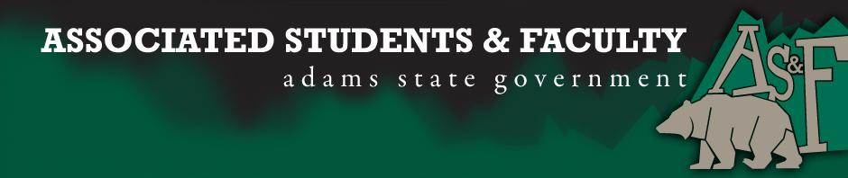

Adams State University Associated Students and Faculty Legislature
Bill Number: ASF1516010

Club Name: English, Theatre, and Communications Department
Event Name or Trip Destination: Senate Seat
Total Amount of AS&F Funding: NA
Total Club Points: NA
Author: Patrick Cleary
Sponsor: Senator Edmonds

Event or Trip Information
Who: Lauren Trujillo
What: Senate Seat
Where: Adams State University
When: 2015-2016 Academic Year
Why: Involvement

Author Contact Information: clearypj@grizzlies.adams.edu

Account Information: NA

Additional Information: Platform.
Objective
My objective is to electively and justly represent the Arts as a Senator through the Associated Student and Faculty Senate.
My name is Lauren Trujillo. I value greatly the opportunity that AS&F has given me to represent the Theater and Art Community, and to further evolve the relationships between the Arts and the Adams State University Community.
What Can I Do For You?
- Represent the Theater and Arts programs and further the interest of the Arts.
- The Arts currently do not have a representative in the Associated Student and Faculty Senate. I would represent the Arts community and create a collaborative effort between the Arts and the AS&F Senate.
- Keep the Arts informed.
- Bring ideas to the AS&F that will help both the Theater and Art Community and the Adams State Community.
- Create a collaboration between the Theater and Art Community and the AS&F Senate.
- To improve relations between the Theater and Art Community and the Adams State University Community.
Qualifications
- Am an active and participating member of the Theater Community.
- Have represented others on student government at the High School level.
- Possess negotiation and public relation skills.
- Have a genuine interest in the Theater and Art community and the AS&F Senate.
My Promise
By electing me as the Arts Senator you will enable us to make important progress and ensure that the Theater and Arts will be represented in the Associated Student and Faculty Senate. Together we can improve the relations between the Arts and the Adams State University community.
My Track Record
When I volunteered in our community I helped set up the Monte Vista Animal Shelter when it was taken over by the current board. I have volunteered at the Conour Animal Shelter since I was eight years old and have spent countless hours rehabilitating dogs and furthering the communication between the Animal Shelter and San Luis Valley Community.
I have also volunteered for the Del Norte Fire Department. I have been involved in the Del Norte Fire Department for much of my life. My father is a Volunteer fireman and I have helped with fund raisers my whole life. I also helped the fire department during the West Fork Fire in 2011 that affected the San Luis Valley.
Community involvement is very important to me. I feel as an Adams State Student I have a duty to help in the Alamosa and San Luis Valley Community.

Assessment Rubric:
Role of a Senator
· Maintain a minimum 2.0 GPA
· Attend all AS&F Meetings
· Sponsor Legislation
· Author Legislation
· Voting power in all matters

I, Patrick Cleary, present this bill for consideration of and approval by the Associated Students and Faculty Senate, this 28th day of September, 2015.

Implementation: Upon approval, be it enacted that:
- The proposed bill become adopted in favor of recognition by the AS&F Senate, and that:
Lauren Trujillo will immediately assume the responsibilities and duties of the office of ETC Senator.

VOTE: Yeas_____ Nays______ Abs_______
Complete applicable sections:
- ADOPTED at ______________ meeting of the AS&F Senate on ___________.
- BILL did not pass at ______________ meeting of the AS&F Senate on ________.
- BILL will be reconsidered on ___________________.

Approved/Disapproved by AS&F President
_______________________________

