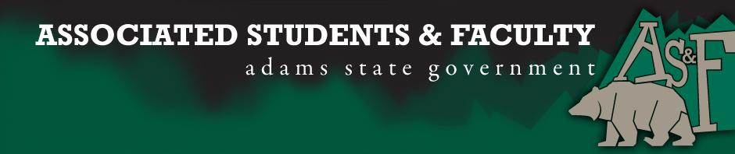

Adams State University Associated Students and Faculty Legislature
Bill Number: ASF1516017

Club Name: Student Athlete Advisory Committee
Event Name or Trip Destination: Senate Seat
Total Amount of AS&F Funding: NA
Total Club Points: NA
Author: Patrick Cleary
Sponsor: Representative King (Poker Club)

Event or Trip Information
Who: Morgan Fitzgibbon
What: SAAC Senate Seat
Where: Adams State University
When: 2015-2016 Academic Year
Why: Involvement

Author Contact Information: clearypj@grizzlies.adams.edu

Account Information: NA

Additional Information (Platform):
Hello, my name is Morgan Fitzgibbon and I am running for the position of SAAC Senator. SAAC is the student athlete advisory committee, for those who do not know. I am a three season athlete here at Adams State, running cross country, indoor track and outdoor track. I am an active member of SAAC participating in as many events as I can. Last year and currently I am the SAAC representative, so I have been on senate for a year now. At Adams state, a large portion of students are also athletes, moving from SAAC representative to SAAC senator would enable someone else to become the representative increasing the representation of student athletes on senate.

Assessment Rubric:
Role of a Senator
· Maintain a minimum 2.0 GPA
· Attend all AS&F Meetings
· Sponsor Legislation
· Author Legislation
· Voting power in all matters

I, Patrick Cleary, present this bill for consideration of and approval by the Associated Students and Faculty Senate, this 12th day of October, 2015.

Implementation: Upon approval, be it enacted that:
- The proposed bill become adopted in favor of recognition by the AS&F Senate, and that:
Morgan Fitzgibbon will immediately assume the responsibilities and duties of the office of SAAC Senator.

VOTE: Yeas_____ Nays______ Abs_______
Complete applicable sections:
- ADOPTED at ______________ meeting of the AS&F Senate on ___________.
- BILL did not pass at ______________ meeting of the AS&F Senate on ________.
- BILL will be reconsidered on ___________________.

Approved/Disapproved by AS&F President
_______________________________

