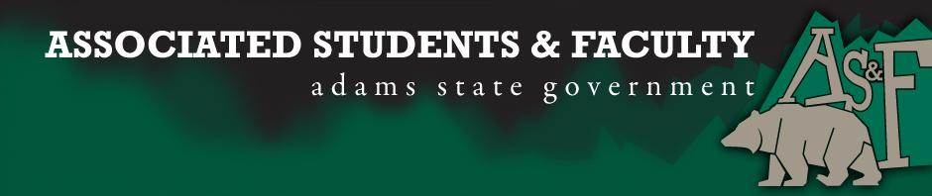

Adams State University Associated Students and Faculty Legislature
Bill Number: ASF1516008

Club Name: Sociology Department
Event Name or Trip Destination: NA
Total Amount of AS&F Funding: NA
Total Club Points: NA
Author: President Cleary
Sponsor: Representative Hargis

Event or Trip Information
Who: Nataly Acurio
What: Senate Seat
Where: Adams State University
When: 2015-2016 Academic Year
Why: Involvement

Author Contact Information: clearypj@grizzlies.adams.edu

Account Information: NA

Additional Information: Student Body,
-I was walking around campus saying hello to random people, when something weird happened.
-I smiled and said hi to two individuals who also said hello to me; shortly after they commented “that was weird”.
-But was it weird?
-Maybe, but that’s not the point.
-The point is for me that being friendly shouldn’t be weird.
-I’ve been involved in AS&F for almost two years in some way or form, as a club representative, senator or other support role.
-Today I stand in front of you all, to tell you that my goal is to make those weird hello’s or hey’s nonexistent.
-Hopefully as your newly elected Sociology Senator, I am able to support ASU students in creating a more inclusive campus filled with non-weird hello’s.
-Whether that be through the sponsoring of bills, or collaboration and support with upcoming events.
-Really if you need help with anything, just let me know.
Thank You,
Nataly Acurio

Assessment Rubric:
Role of a Senator
· Maintain a minimum 2.0 GPA
· Attend all AS&F Meetings
· Sponsor Legislation
· Author Legislation
· Voting power in all matters

I, President Cleary, present this bill for consideration of and approval by the Associated Students and Faculty Senate, this 31st day of August, 2015.

Implementation: Upon approval, be it enacted that:
- The proposed bill become adopted in favor of recognition by the AS&F Senate, and that:
Nataly Acurio will immediately assume the responsibilities and duties of the office of Sociology Senator.

VOTE: Yeas_____ Nays______ Abs_______
Complete applicable sections:
- ADOPTED at ______1st________ meeting of the AS&F Senate on _____8/31/15______.
- BILL did not pass at ______________ meeting of the AS&F Senate on ________.
- BILL will be reconsidered on ___________________.

Approved/Disapproved by AS&F President
______________Patrick Cleary_________________

