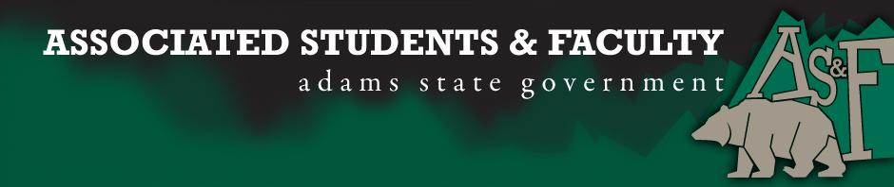

Adams State University Associated Students and Faculty Legislature
Bill Number: ASF1516007

Club Name: Business Department
Event Name or Trip Destination: NA
Total Amount of AS&F Funding: NA
Total Club Points: NA
Author: President Cleary
Sponsor: Representative Hargis

Event or Trip Information
Who: John Owsley
What: Senate Seat
Where: Adams State University
When: 2015-2016 Academic Year
Why: Involvement

Author Contact Information: clearypj@grizzlies.adams.edu

Account Information: NA

Additional Information: After writing this platform once, and then forgetting to save it. I guess I’ll just have to make it a little more authentic. Like most of you here, I came here to Adams State so I can get a strong affordable education. It has only been a week of classes and so far I know I made the right choice. But going to college, as many of you all know, is not all about education. It’s about the experience and the journey. I want to become an AS&F Senator so I can to make the most of my experience here and hopefully help others to do the same. If you were to elect me as your next senator, I promise to do my best to be approachable enough for people to feel comfortable voicing their concerns. I promise to bring a lively attitude and a positive energy in and out of meetings. And finally, I promise to love ASU just as much as the reasons that brought all of us here to attend this incredible opportunity. Thank you.

Assessment Rubric:
Role of a Senator
· Maintain a minimum 2.0 GPA
· Attend all AS&F Meetings
· Sponsor Legislation
· Author Legislation
· Voting power in all matters

I, President Cleary, present this bill for consideration of and approval by the Associated Students and Faculty Senate, this 31st day of August, 2015.

Implementation: Upon approval, be it enacted that:
- The proposed bill become adopted in favor of recognition by the AS&F Senate, and that:
John Owsley will immediately assume the responsibilities and duties of the office of Business Senator.

VOTE: Yeas_____ Nays______ Abs_______
Complete applicable sections:
- ADOPTED at _______1st_______ meeting of the AS&F Senate on _____8/31/15______.
- BILL did not pass at ______________ meeting of the AS&F Senate on ________.
- BILL will be reconsidered on ___________________.

Approved/Disapproved by AS&F President
_____________Patrick Cleary__________________

