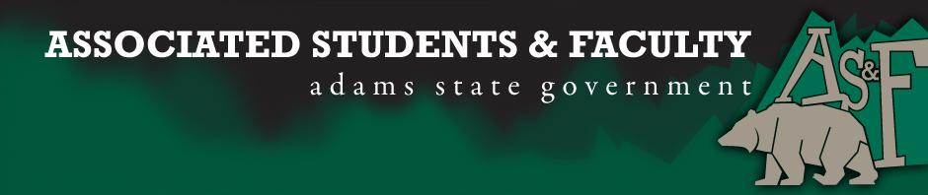

Adams State University Associated Students and Faculty Legislature
Bill Number: ASF1516005

Club Name: Business Department
Event Name or Trip Destination: NA
Total Amount of AS&F Funding: NA
Total Club Points: NA
Author: President Cleary
Sponsor: Representative Hargis

Event or Trip Information
Who: Brenna Rivale
What: Senate Seat
Where: Adams State University
When: 2015-2016 Academic Year
Why: Involvement

Author Contact Information: clearypj@grizzlies.adams.edu

Account Information: NA

Additional Information: If elected as AS&F Senator, I Brenna Rivale, want to be the voice of Adams State students. I want to fix what needs to be fixed and help make a difference on campus. I want to bring all groups together to create a sense of community. A community where everyone is welcomed with open arms and no one feels grey in a black and white world. Adams State University helps drive Alamosa and surrounding cities. I wish to use that drive to bring together students, faculty and community members to help create and shape tomorrow’s great minds. I wish to shape a brighter future for all Adams State students. I will try my hardest to accomplish my goals for this great university if given the opportunity. Thank you.

Assessment Rubric:
Role of a Senator
· Maintain a minimum 2.0 GPA
· Attend all AS&F Meetings
· Sponsor Legislation
· Author Legislation
· Voting power in all matters

I, President Cleary, present this bill for consideration of and approval by the Associated Students and Faculty Senate, this 31st day of August, 2015.

Implementation: Upon approval, be it enacted that:
- The proposed bill become adopted in favor of recognition by the AS&F Senate, and that:
Brenna Rivale will immediately assume the responsibilities and duties of the office of Business Senator.

VOTE: Yeas_____ Nays______ Abs_______
Complete applicable sections:
- ADOPTED at ______1st________ meeting of the AS&F Senate on ____8/31/15_______.
- BILL did not pass at ______________ meeting of the AS&F Senate on ________.
- BILL will be reconsidered on ___________________.

Approved/Disapproved by AS&F President
___________Patrick Cleary____________________

