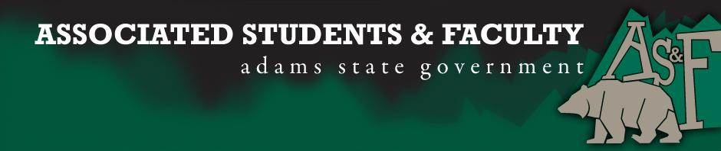

Adams State University Associated Students and Faculty Legislature
Bill Number: ASF1516003

Club Name: AS&F Senate
Event Name or Trip Destination: NA
Total Amount of AS&F Funding: NA
Total Club Points: NA
Author: President Cleary
Sponsor: Representative Hargis

Event or Trip Information
Who: Aaron Davis
What: Freshmen Senator
Where: Adams State University
When: 2015-2016 Academic Year
Why: Involvement

Author Contact Information: clearypj@grizzlies.adams.edu

Account Information: NA

Additional Information: I wish to be a freshman senator this year because I am passionate about helping and improving my school. I am dedicated to hard work and will go to extreme measures to help others. I was involved in student government in high school and I enjoyed it more than any group on campus. As a high school senator I helped our Presidents and faculty with whatever was needed, I planned and set up events, I aided in maintaining a fun, safe, and educational environment, and I represented my school with pride. Because of my experience in student government, I believe my trait of leadership has strongly grown. As a freshman senator in AS&F, I hope to be a voice for my school and fellow students, I hope to be of help to AS&F and to my school, and I hope to put my leadership skills to work. I will always strive for the greater good and that is what would make me a great representative of Adams State University.

Assessment Rubric:
Role of a Senator
· Maintain a minimum 2.0 GPA
· Attend all AS&F Meetings
· Sponsor Legislation
· Author Legislation
· Voting power in all matters

I, President Cleary, present this bill for consideration of and approval by the Associated Students and Faculty Senate, this 31st day of August, 2015.

Implementation: Upon approval, be it enacted that:
- The proposed bill become adopted in favor of recognition by the AS&F Senate, and that:
Aaron Davis will immediately assume the responsibilities and duties of the office of Freshmen Senator.

VOTE: Yeas_____ Nays______ Abs_______
Complete applicable sections:
- ADOPTED at _______1st_______ meeting of the AS&F Senate on ____8/31/15_______.
- BILL did not pass at ______________ meeting of the AS&F Senate on ________.
- BILL will be reconsidered on ___________________.

Approved/Disapproved by AS&F President
____________Patrick Cleary___________________

