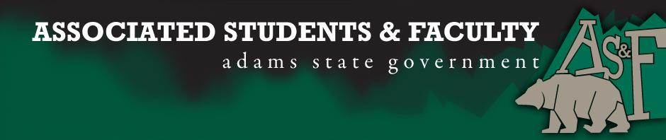

Adams State University Associated Students and Faculty Legislature
Bill Number: ASF1516002

Club Name: Grizzly Activity Board
Event Name or Trip Destination: NA
Total Amount of AS&F Funding: NA
Total Club Points: NA
Author: President Cleary
Sponsor: Representative Hargis

Event or Trip Information
Who: Matthew Tulley
What: GAB Senator
Where: Adams State University
When: 2015-2016 Academic Year
Why: Involvement

Author Contact Information: clearypj@grizzlies.adams.edu

Account Information: NA

Additional Information: I want to be the GAB Senator to help the communication between GAB and AS&F flourish, whether it be on a bill, for funding, or for rights within the organization. As a member of GAB and a Senator I’ll be able to communicate the needs of the organization directly to AS&F. I’ll have a voice not only in GAB, but in AS&F that will provide better representation.

Assessment Rubric:
Role of a Senator
· Maintain a minimum 2.0 GPA
· Attend all AS&F Meetings
· Sponsor Legislation
· Author Legislation
· Voting power in all matters

I, President Cleary, present this bill for consideration of and approval by the Associated Students and Faculty Senate, this 31st day of August, 2015.

Implementation: Upon approval, be it enacted that:
- The proposed bill become adopted in favor of recognition by the AS&F Senate, and that:
Matthew Tulley will immediately assume the responsibilities and duties of the office of GAB Senator.

VOTE: Yeas_____ Nays______ Abs_______
Complete applicable sections:
- ADOPTED at ______1st________ meeting of the AS&F Senate on ____8/31/15_______.
- BILL did not pass at ______________ meeting of the AS&F Senate on ________.
- BILL will be reconsidered on ___________________.

Approved/Disapproved by AS&F President
______________Patrick Cleary_________________

