Student Government Bill Guideline Travel Funding Request Form
- Choose the Funding Request Form (Nov. 2011).
- Choose File
  - Download as:
  - Excel
  - Choose to Open the document.
  - This will cause the file to open into a sheet in which you can add the needed information (note: the file is going to open up in an excel spreadsheet so you must have access to excel software).
- Once in excel, choose the Enable Editing option if prompted.
- The first information you should place in the document is the number of points your club has accumulated in that academic year.
  - Example : 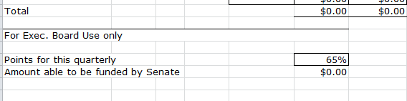
- You may then continue to enter the information about your trip.
- Important Reminders:
  - All calculations will be done by the equations set up in the document. Please do not input any information in the boxes found under the headings Fund or Cost. Only enter information in columns A-E that pertain to your request. In addition, the amount to be funded by senate (as seen above) will be calculated for you as well. Boxes completely outlined are set up for you to enter information.
  - The mileage is already set up to account for your return trip; therefore, you only need to enter the one way mileage.
  - Please do not try to change the per diem rates denoted in italics. ($70/night for hotel, $46/person/day for food) They are set by the state. If you find that you will not need the total amount, please see an AS&F executive member and they will help you to change the document as needed.
  - Remember that the limit for international air travel is $1000 for up to seven individuals; therefore, the request may not be above $7000.
  - If there are any other questions, please feel free to contact us at:
Phone: (719) 587-7948
Email:asf@grizzlies.adams.edu

