Student Government Bill Guideline Event Funding Request Form
- Choose the Event Funding Request Form
- Choose File
  - Download as:
  - Excel
  - This will cause the file to open into a sheet in which you can add the needed information (note: the file is going to open up in an excel spreadsheet so you must have access to excel software).
- Once in excel, choose the Enable Editing option if prompted.
- The first information you should place in the document is the number of points your club has accumulated in that academic year:
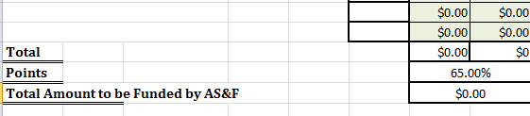
- You may then continue to enter the information about your trip.
- Important Reminders:
  - Please only fill out the boxes under the headings Activities, Food, Promotional Items, Speaker, Miscellaneous, Cost, and Points. (Columns A-F)
  - If there are any other questions, please feel free to contact us at:
Phone: (719) 587-7948
Email:asf@grizzlies.adams.edu

