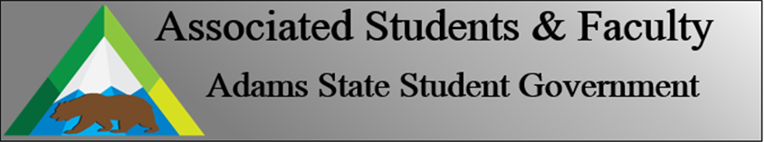

Adams State University Associated Students and Faculty Legislature
Bill Number: ASF1718019

Club Name: Campus Impact Fund Committee
Event Name or Trip Destination: Campus Impact Fund Proposals
Total Amount of AS&F Funding:
Total Club Points: N/A
Author: Cody Trujillo
Sponsor: Brenna Rivale

Event or Trip Information
Who: CIF Committee
What: Asking the Senate to approve the CIF proposals
Where: N/A
When: N/A
Why: These proposals create and spread new ideas, research, and ways of thinking to the Campus and community. Adams State University will grow as a community from each proposal being funded.

Author Contact Information: Trujillocm3@grizzlies.adams.edu

Account Information: N/A

Additional Information: N/A

Assessment Rubric:
What do you want people attending the event, program, or going on the trip to gain from this experience? (Required for funding requests) (Check/circle all that apply)

x Expanding the Learning Experience
x Analytical Reasoning
x Internal Self-Development
x Improving Teamwork and Leadership
x Community Service and Civic Engagement
x External Skill Development

Please define how your event, program, or trip will help people gain from this experience according to the goals you have checked.

Expanding the Learning Experience:
By funding the independent research, we are allowed a deeper look into the six specific variations in attitudes and behaviors which have been described being universal throughout all cultures. Not only will the individual benefit from this research, but the findings will be presented at Student Scholar days which will be available to everyone on Campus.

Analytical Reasoning:
By submitting surveys on a national level, we are honing the ability to analyze large amounts of data and transform it into hypotheses.

Internal Self-Development:
By spreading the awareness and culture of different holidays, we are facilitating not only Self-Development but the development of others. Día de los Muertos is opening the Spanish culture to others to offer a better understanding to those who may not be versed in its traditions.

Improving Teamwork and Leadership:
The Thanksgiving dinner will offer speakers, pamphlets, and Thanksgiving information to ASU students and people from the community. By pairing with La Mesa Dining Hall, teamwork and leadership skills will be improved within the groups hosting the dinner.

Community Service and Civic Engagement:
The purpose of all events are to provide additional information to the community and engage with the community in a variety of different ways. The community service and civic engagement range from educating the public and campus about a new study to providing services to people who might otherwise not have the opportunity to participate in.

External Development:
By presenting new ways of thinking, others will take new actions to develop themselves externally. In doing this, Adams State University is not the sole beneficiary of the proposals; a butterfly effect will take place, changing the lives of others in a multitude of small ways.

I, Cody Trujillo, present this bill for consideration of and approval by the Associated Students and Faculty Senate, this 23rd day of October, 2017.

Implementation: Upon approval, be it enacted that:
- The proposed bill become adopted in favor of recognition by the AS&F Senate

VOTE: Yeas_____ Nays______ Abs_______
Complete applicable sections:
- ADOPTED at ______________ meeting of the AS&F Senate on ___________.
- BILL did not pass at ______________ meeting of the AS&F Senate on ________.
- BILL will be reconsidered on ___________________.

Approved/Disapproved by AS&F President
_______________________________

