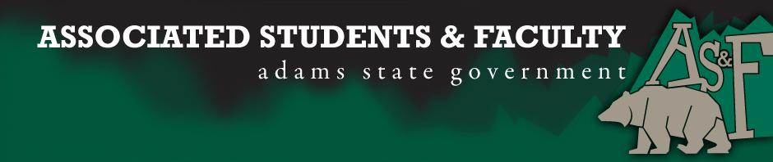

Adams State University Associated Students and Faculty Legislature
Bill Number: ASF1718012

Club Name: (Bulls and Bears)
Event Name or Trip Destination: (Denver, Colorado)
Total Amount of AS&F Funding: ($1,940.84)
Total Club Points: (55)
Author: (Snowy Coleman)
Sponsor: (Chelsea Walljasper)

Event or Trip Information
Who: (Adams State Finance Students)
What: (Bank Internship Tours)
Where: (Denver, Colorado)
When: (November 6th)
Why: (To see what the finance world has to offer Adams State Students, and to better the outcome of graduating students of Adams State University receiving proper training for their careers after graduation. We want our school to have a higher success rate. The bank supervisors will teach us what it takes to be in the finance industry, we will then come back to A.S.U and share the information gathered in a presentation for the School of Business. This is not a career fair event, we are not going with the intention of receiving a job, we are going for knowledge and training)

Author Contact Information: (Snowy Coleman)

Account Information: (3200-855-xxxx-1900)

Additional Information: (We want to have a higher success rate with employment for Adams State Universty so that new students)

Assessment Rubric:
What do you want people attending the event, program, or going on the trip to gain from this experience? (Required for funding requests) (Check/circle all that apply)

· Expanding the Learning Experience
· Analytical Reasoning
· Internal Self-Development
· Improving Teamwork and Leadership
· Community Service and Civic Engagement
· External Skill Development

This will expand our clubs learning experience by showing them what the real world of Finance requires for success. They will learn analytical reasoning through asking questions to the banks executives. They will gain confidence in their knowledge attained through Adams State and by exhibiting their skills in the banking world.

I, (Snowy Coleman), present this bill for consideration of and approval by the Associated Students and Faculty Senate, this (25th) day of (September), 20 (17).

Implementation: Upon approval, be it enacted that:
- The proposed bill become adopted in favor of recognition by the AS&F Senate, and that:
- (Bulls and Bears) be funded (1,940.84)

VOTE: Yeas_____ Nays______ Abs_______
Complete applicable sections:
- ADOPTED at ______________ meeting of the AS&F Senate on ___________.
- BILL did not pass at ______________ meeting of the AS&F Senate on ________.
- BILL will be reconsidered on ___________________.

Approved/Disapproved by AS&F President
_______________________________

