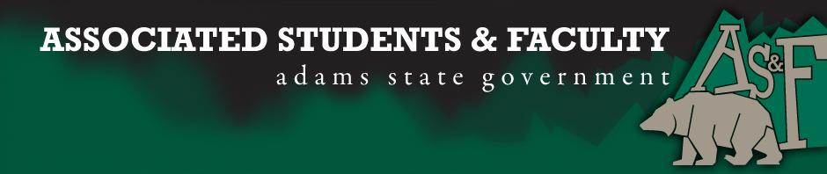

Adams State University Associated Students and Faculty Legislature
Bill Number: ASF1718011

Club Name: Adams Atoms
Event Name or Trip Destination: ACS New Orleans
Total Amount of AS&F Funding: $6682.90
Total Club Points: 71
Author: Otto Schaefer
Sponsor: Caroline Steen

Event or Trip Information
Who: This trip is only extended to members of the ACS chapter “Adams Atoms”
What: Attending a national conference where 2 students will be presenting undergraduate research.
Where: New Orleans, Louisiana
When: March 18th – March 22nd 2017
Why: To gain knowledge of how the industry is like actually.

Author Contact Information: Otto Schaefer
Schaeferoz@grizzlies.adams.edu
575-392-8788

Account Information: 3200-846-7630-1900

Additional Information: Adams Atoms has brought awards in community outreach in the science for previous years. Our main goal is bringing home the gold award which proves that Adams State University is above par when it comes to getting the community involved with academics.

Assessment Rubric:
What do you want people attending the event, program, or going on the trip to gain from this experience? (Required for funding requests) (Check/circle all that apply)

· Expanding the Learning Experience √
· Analytical Reasoning
· Internal Self-Development √
· Improving Teamwork and Leadership √
· Community Service and Civic Engagement
· External Skill Development

Please define how your event, program, or trip will help people gain from this experience according to the goals you have checked.

I previously was a first time attendee to this national conference. This conference provides and experience that is unparalleled. Attendee are able to get some useful information when it comes to looking for grad schools as well as information pertaining to cutting edge research and products used in industry. The attendance of this conference reaches around 21,000 members. This is a great opportunity to network with those who are already well established in industry.

I, Otto Schaefer, present this bill for consideration of and approval by the Associated Students and Faculty Senate, this (25) day of (September), 20 (17).

Implementation: Upon approval, be it enacted that:
- The proposed bill become adopted in favor of recognition by the AS&F Senate, and that:
- Adams Atoms be funded $4750.90

VOTE: Yeas_____ Nays______ Abs_______
Complete applicable sections:
- ADOPTED at ______________ meeting of the AS&F Senate on ___________.
- BILL did not pass at ______________ meeting of the AS&F Senate on ________.
- BILL will be reconsidered on ___________________.

Approved/Disapproved by AS&F President
_______________________________

