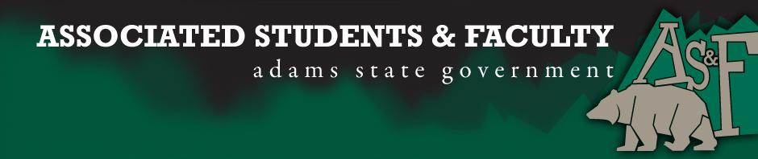

Adams State University Associated Students and Faculty Legislature
Bill Number: ASF1718010

Club Name: N/A
Event Name or Trip Destination: Association for Applied Sport Psychology Conference 2017
Total Amount of AS&F Funding: 40% of 1,040 = $416
Total Club Points: (All points club has to date, can be over 70) (required)
Author: Martin Wolffe/ Nicholas Jauregui
Sponsor: HPPE Senator Hovasse

Event or Trip Information
Who: Adams State University, Applied Sport Psychology graduate students (4)
What: Attending workshops on Sport Psychology with leaders in the field
Where: Orlando Florida
When: October 17-22
Why: Gain knowledge from the leaders in our field, and bring that back to the University so we can help provide services for student athletes and others.
Author Contact Information: Martin Wolffe - 719-480-1906 wolffemk@grizzlies.adams.edu

Account Information: (1100-1721-7300-1100)

Additional Information: We will be meeting the best in the field, USOC Sport Psychologists, College Coaches, MLB Sport Psychologists etc.
Assessment Rubric:
What do you want people attending the event, program, or going on the trip to gain from this experience? (Required for funding requests) (Check/circle all that apply)

· Expanding the Learning Experience (x)
· Analytical Reasoning (x)
· Internal Self-Development (x)
· Improving Teamwork and Leadership (x)
· Community Service and Civic Engagement (x)
· External Skill Development

Please define how your event, program, or trip will help people gain from this experience according to the goals you have checked.
(Please define only the boxes checked)

Through this conference, we as graduate students in the field of Applied Sport Psychology will be able to build on the knowledge we currently have by interacting and learning from the leaders in our field. Our reasoning will be enhanced due to the different perspectives we will encounter while at the conference. This opportunity will help develop each individual as a mental strength coach/sport psychologist as we will each learn things that will help mold who we are as professionals. Through this experience we will be exposed to strategies used by those above us and will look at how we as a cohort can implement those strategies here at Adams State University with the student athletes and general student body population.

I, (Martin Wolffe or Nicholas Jauregui), present this bill for consideration of and approval by the Associated Students and Faculty Senate, this (25th) day of (September), 2017.

Implementation: Upon approval, be it enacted that:
- The proposed bill become adopted in favor of recognition by the AS&F Senate, and that:
- (Club Name) be funded (Amount Requested)

VOTE: Yeas_____ Nays______ Abs_______
Complete applicable sections:
- ADOPTED at ______________ meeting of the AS&F Senate on ___________.
- BILL did not pass at ______________ meeting of the AS&F Senate on ________.
- BILL will be reconsidered on ___________________.

Approved/Disapproved by AS&F President
_______________________________

