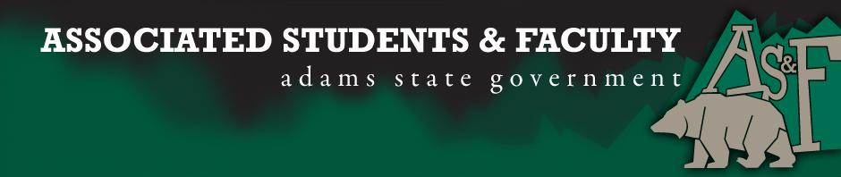

Adams State University Associated Students and Faculty Legislature
Bill Number: ASF1718009

Club Name: Pen and Inkwell: A Writer’s Guild
Event Name or Trip Destination: AWP 2018, Tampa, Florida
Total Amount of AS&F Funding: 2,095.38
Total Club Points: 63
Author: Jasmyn Brendle
Sponsor: Chelsea Walljasper

Event or Trip Information
Who: Club Members
What: Writing Conference
Where: Tampa, Florida
When: March 4-11,2018
Why: To further expand our cultural and education minds. This will be the 3rd year running, and we hope to bring back even more to campus.

Author Contact Information:
Jasmyn Brendle
penandinkwellwritersguild@gmail.com
brendlejn@grizzlies.adams.edu
Account Information:
3200-854-7630-1900

Additional Information:
We will also being visiting museums and other locations that will expand our views of the world and influence our writing and other creative works.

Assessment Rubric:
What do you want people attending the event, program, or going on the trip to gain from this experience?

· Expanding the Learning Experience X
· Analytical Reasoning
· Internal Self-Development X
· Improving Teamwork and Leadership X
· Community Service and Civic Engagement
· External Skill Development X

Traveling to the AWP Conference for the third year in a row, will help us solidify our connections with the large writing community we established last year, as well as give us the opportunity to attract future students to ASU. This conference will help us network with future employers and develop better leadership and strengthen our networking connections with other universities and presses to get our names out into the community. We are also using this trip to broaden our horizons in terms of culture and history by visiting museums, art galleries, and shows.

I, Jasmyn Brendle, present this bill for consideration of and approval by the Associated Students and Faculty Senate, this 25, September, 2017.

Implementation: Upon approval, be it enacted that:
- The proposed bill become adopted in favor of recognition by the AS&F Senate, and that:
- Pen and Inkwell be funded $2,095.38

VOTE: Yeas_____ Nays______ Abs_______
Complete applicable sections:
- ADOPTED at ______________ meeting of the AS&F Senate on ___________.
- BILL did not pass at ______________ meeting of the AS&F Senate on ________.
- BILL will be reconsidered on ___________________.

Approved/Disapproved by AS&F President
_______________________________

