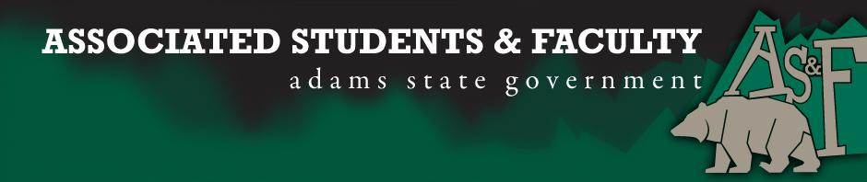

Adams State University Associated Students and Faculty Legislature
Bill Number: ASF1718007

Club Name: PHITE Club
Event Name or Trip Destination: NASPA General Assembly Conference in Denver, Colorado
Total Amount of AS&F Funding: $2,181.59
Total Club Points: 81
Author: Sam Wall
Sponsor: Chelsea Walljasper

Event or Trip Information
Who: PHITE Club will be participating and potentially presenting at the The BACCHUS Initiatives of NASPA General Assembly Conference in Denver, Colorado. Only PHITE club members/students will be attending.
What: Attending the NASPA General Assembly in Denver, Colorado to present on our ongoing Animals Assisted Activity (Paws and Relax) and participate in conference programing/activites.
Where: Denver, Colorado: Denver Marriott City Center, 1701 California Street, Denver, CO 80202
When: Wednesday, November 15 - Saturday, November 18 (Sunday, November 19th: Travel Day)
Why: We will be attending the conference to hopefully present the Animal Assisted activity (Paws and Relax) the at we have been doing on campus for a little under a year, and plan to continue. The presentation will include how it has been beneficial on our campus and how other campuses can explore the idea of creating a similar program. We will also be able to hear from other schools on how they provide Individual health awareness whether it spiritual, mental, physical, emotional health.

Author Contact Information: chelsea.walljasper@gmail.com

Account Information: 3200 852 76301900

Additional Information:
- For our members to go they must fill out an application that is reviewed by our advisor. The application consists of a GPA check and a Selection criteria will be based upon a written essay of no more than two pages that summarize the following:
- How you will use the information learned at the conference to change our campus
- Your current campus leadership experiences
- Your role as a peer educator on campus/in the club
- Why you should receive funding to attend the conference
- We have submitted a program to present students researched work and our club’s success the implication and the reason for Animal Assisted Activities on campus through collaboration with campus resources.
Assessment Rubric:
What do you want people attending the event, program, or going on the trip to gain from this experience?

· Expanding the Learning Experience ✓
· Analytical Reasoning
· Internal Self-Development ✓
· Improving Teamwork and Leadership ✓
· Community Service and Civic Engagement
· External Skill Development ✓

Expanding the Learning Experience: This conference will give the opportunity for students to learn about the progressing fields of prevention awareness and learn how to really make prevention and awareness efforts on campus stronger. While also learning how to better support students, as peers.
Internal Self-Development: This conference will provide the individuals going presenter experience and networking opportunities with other universities to bring awareness efforts and ideas back to our campus from surrounding Universities. As well as helping them develop the skills and information they need to engage in critical and difficult conversations around prevention and awareness.
Improving teamwork and Leadership: This conference is a great opportunity to help our students going and bring back to the campus what it means to be a peer educator and a prevention/awareness advocate. While also understanding the need for support in a team and social setting to set and accomplish goals for the semester in regards to becoming a strong presence on campus to help keep and encourage a safe and welcoming campus.
External Skill Development: Students will gain presenter experience and learn how to be a positive and effective peer educator on campus while also hearing from other universities what type of prevention awareness programs have worked for them in the past so we can better equip our members with the knowledge and skills to bring some of those ideas back to our campus.

I, Sam Wall, present this bill for consideration of and approval by the Associated Students and Faculty Senate, this 25th day of September, 2017.

Implementation: Upon approval, be it enacted that:
- The proposed bill become adopted in favor of recognition by the AS&F Senate, and that:
- PHITE CLUB be funded $2,181.59

VOTE: Yeas_____ Nays______ Abs_______
Complete applicable sections:
- ADOPTED at ______________ meeting of the AS&F Senate on ___________.
- BILL did not pass at ______________ meeting of the AS&F Senate on ________.
- BILL will be reconsidered on ___________________.

Approved/Disapproved by AS&F President
_______________________________

