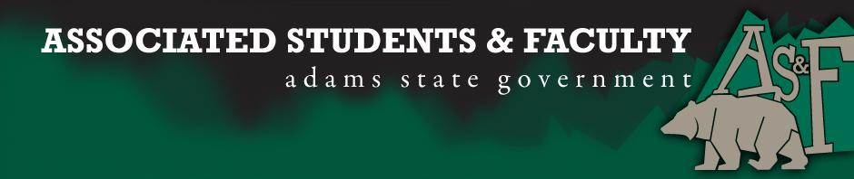

Adams State University Associated Students and Faculty Legislature
Bill Number: ASF1718005

Club Name: ASU Phi Beta Lambda
Event Name or Trip Destination: State Leadership Conference
Total Amount of AS&F Funding: $3,180.94
Total Club Points: 65
Author: Abbey Stagner
Sponsor: Janet Najar

Event or Trip Information
Who: Members and 1 Advisor
What: State Conference
Where: Expected Grand Junction
When: April 13,14,15, 2018
Why: To gain funding to support our annual state competition.

Author Contact Information: Abbey Stagner, 719-588-0756, stagneral1@grizzlies.adams.edu

Account Information: 3200-839-xxx-1900

Additional Information: This is an annual competition last year we had nine students compete and all nine qualified to attend the National Conference. We are looking forward to having similar success.

Assessment Rubric:
What do you want people attending the event, program, or going on the trip to gain from this experience?

· Expanding the Learning Experience
· Analytical Reasoning
· Internal Self-Development
· Improving Teamwork and Leadership
· Community Service and Civic Engagement
· External Skill Development

Please define how your event, program, or trip will help people gain from this experience according to the goals you have checked.
Members participate in events testing various areas of business, public speaking, client services and numerous others. This is also a great networking opportunity.

I, Abbey Stagner, present this bill for consideration of and approval by the Associated Students and Faculty Senate, this 25th day of September 2017.

Implementation: Upon approval, be it enacted that:
- The proposed bill become adopted in favor of recognition by the AS&F Senate, and that:
- ASU Phi Beta Lambda be funded $3180.94.

VOTE: Yeas_____ Nays______ Abs_______
Complete applicable sections:
- ADOPTED at ______________ meeting of the AS&F Senate on ___________.
- BILL did not pass at ______________ meeting of the AS&F Senate on ________.
- BILL will be reconsidered on ___________________.

Approved/Disapproved by AS&F President
_______________________________

