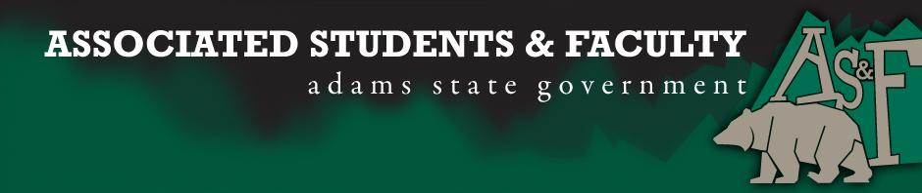
Adams State University Associated Students and Faculty Legislature
Bill Number: ASF1718003

Club Name: Grizzly Actively Board Senator
Event Name or Trip Destination: Senate Seat
Total Amount of AS&F Funding: NA
Total Club Points: NA
Author: Sean Erice
Sponsor: Breanna Rivale

Event or Trip Information
Who: Marquel Parks
What: Grizzly Actively Board Senator Seat
Where: Adams State University
When: 2017-2018 Academic Year
Why: Involvement

Author Contact Information: ericesj@grizzlies.adams.edu

Account Information: NA

Additional Information (Platform): I would like to hold a senate position as a representative for GAB. GAB is currently in need of representation within our student government so as to better promote the events we organize on campus. In being able to communicate these events with the other clubs via announcements at the end of AS&F meetings, I hope to create a better effectiveness of promotion for our club. I also feel that I can represent the student body in policy implementation from a unique standpoint as a GAB Senator in the fact that GAB is based around the ideal of unity within diverse groups and our campus community. It is my personal desire to be a leader on campus and in general, holding a position such as this I believe will secure that title.

Assessment Rubric:
Role of a Senator
· Maintain a minimum 2.0 GPA
· Attend all AS&F Meetings
· Sponsor Legislation
· Author Legislation
· Voting power in all matters

I, Sean Erice, present this bill for consideration of and approval by the Associated Students and Faculty Senate, this 25th day of September, 2017.

Implementation: Upon approval, be it enacted that:
- The proposed bill become adopted in favor of recognition by the AS&F Senate, and that:
Marquel Parks will immediately assume the responsibilities and duties of the office of Grizzly Actively Board Senator

VOTE: Yeas_____ Nays______ Abs_______
Complete applicable sections:
- ADOPTED at ______________ meeting of the AS&F Senate on ___________.
- BILL did not pass at ______________ meeting of the AS&F Senate on ________.
- BILL will be reconsidered on ___________________.

Approved/Disapproved by AS&F President
_______________________________

