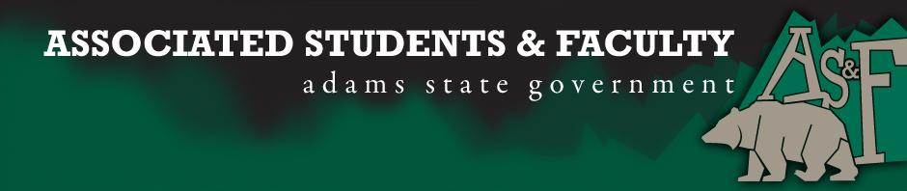

Adams State University Associated Students and Faculty Legislature
Bill Number: ASF1718002

Club Name: English. Theatre, and Communications Senator
Event Name or Trip Destination: Senate Seat
Total Amount of AS&F Funding: NA
Total Club Points: NA
Author: Sean Erice
Sponsor: Breanna Rivale

Event or Trip Information
Who: Hanna Atkinson
What: English. Theatre, and Communications Senator
Where: Adams State University
When: 2017-2018 Academic Year
Why: Involvement

Author Contact Information: ericesj@grizzlies.adams.edu

Account Information: NA

Additional Information (Platform): On the eve of my tenth year of life, I made two important decisions. Firstly, I decided that I was destined to be a volleyball player. Secondly, that I would save the planet. Over a decade later, I find myself in the midst of my first decision coming to s less-than-delicate close. My identity, while slightly shaken, is not crumbling. For that “I thank whatever gods may be for my unconquerable soul AS&F may not be my end goal of making the planet a better place. Neither will beginning a spin class or joining EARTH Club, but to promote a stronger community of young and old weak, powerful, different genders, ethnicities, backgrounds and preferences…this may be the place for me to begin.

Assessment Rubric:
Role of a Senator
· Maintain a minimum 2.0 GPA
· Attend all AS&F Meetings
· Sponsor Legislation
· Author Legislation
· Voting power in all matters

I, Sean Erice, present this bill for consideration of and approval by the Associated Students and Faculty Senate, this 25th day of September, 2017.

Implementation: Upon approval, be it enacted that:
- The proposed bill become adopted in favor of recognition by the AS&F Senate, and that:
Hannah Atkinson and will immediately assume the responsibilities and duties of the office of English. Theatre, and Communications Senator.

VOTE: Yeas_____ Nays______ Abs_______
Complete applicable sections:
- ADOPTED at ______________ meeting of the AS&F Senate on ___________.
- BILL did not pass at ______________ meeting of the AS&F Senate on ________.
- BILL will be reconsidered on ___________________.

Approved/Disapproved by AS&F President
_______________________________

