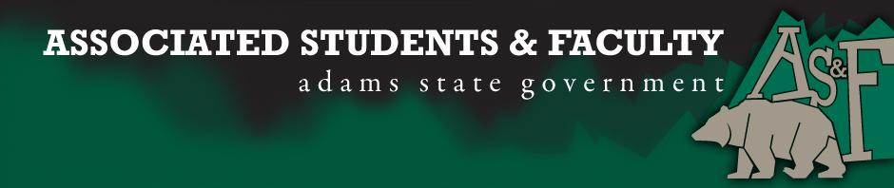

Adams State University Associated Students and Faculty Legislature
Bill Number: ASF1718001

Club Name: Student Athlete Advisory Committee (SAAC)
Author: Tyler Copeland
Sponsor: Dianne Lee

What: SAAC would like to become an AS&F recognized club.

Why: The mission of Student-Athlete Advisory Committees is to enhance the total student-athlete experience by promoting opportunity, protecting student-athlete welfare and fostering a positive student-athlete image.

Author Contact Information: Email: copelandtj@grizzlies.adams.edu Phone: (503) 396-8787.

Additional Information:
Student-athlete advisory committee (SAAC) is a committee made up of student-athletes assembled to provide insight on the student-athlete experience and to offer input on the rules, regulations and polices that affect student-athletes' lives on NCAA member institution campuses.

I, Tyler Copeland, present this bill for consideration of and approval by the Associated Students and Faculty Senate, on the 25th day of September 2017.

Implementation: Upon approval, be it enacted that:
- The proposed bill become adopted in favor of recognition by the AS&F Senate, and that:
- SAAC become an AS&F recognized club.

VOTE: Yeas_____ Nays______ Abs_______
Complete applicable sections:
- ADOPTED at ______________ meeting of the AS&F Senate on ___________.
- BILL did not pass at ______________ meeting of the AS&F Senate on ________.
- BILL will be reconsidered on ___________________.

Approved/Disapproved by AS&F President
_______________________________

