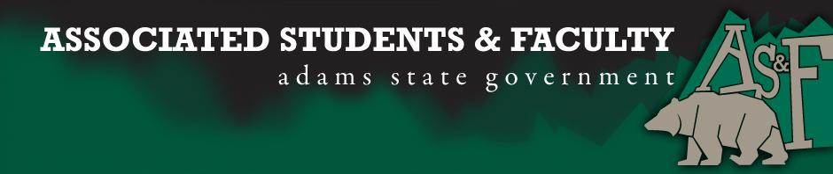
Adams State University Associated Students and Faculty Legislature
Bill Number: ASF1617037

Club Name: ASU Bulls & Bears Finance Club
Event Name or Trip Destination: Denver, Colorado
Total Amount of AS&F Funding: $975.63
Total Club Points: 55
Author: Jakob Koons/Angela Gallegos
Sponsor: Sean Erice

Event or Trip Information
Who: Participating members will be involved as well as the head of the finance program.
What: Take guided tour of the United States mint. Visit multiple corporate banks.
When: November, 17-19, 2016
Why: Looking to take a local trip to gain new connections and new insights of banking via Bank of America, 1st Bank, and Alpine Bank. Learn how American currencies are created, distributed and circulated through the population of America.

Author Contact Information: Jakob Koons: (303)-810-7829.
Email: Koonsja@grizzlies.adams.edu
Angela Gallegos:
Email: Gallegosa4@grizzlies.adams.edu

Account Information: 3200-855-7630-1900

Additional Information: Looking to bring back a once successful finance club with a very insightful local trip

Assessment Rubric:
What do you want people attending the event, program, or going on the trip to gain from this experience? (Required for funding requests) (Check/circle all that apply)

- Expanding the Learning Experience
· Analytical Reasoning
- Internal Self-Development
· Improving Teamwork and Leadership
· Community Service and Civic Engagement
  - External Skill Development

Please define how your event, program, or trip will help people gain from this experience according to the goals you have checked.

- Expanding the Learning Experience:
  - By visiting multiple banks and the United States Mint, this will provide a new aspect of the world of finance, adding in the creation a currency and the ways to store currency.
- External Skill Development
  - By visiting investment mangers, participants will learn the importance of being proficient at analyzing financial information relating to their company account, fin market analysis, profit or loss and cash-flow statements.
- Internal Self-development
  - Through traveling as a club and visiting multiple big banks as well as the United States mint, members of the club will increase their skills and knowledge on the world of finance, this in return will increase internal self-development.

I, Jakob Koons, present this bill for consideration of and approval by the Associated Students and Faculty Senate, this 7th day of November, 2016.

Implementation: Upon approval, be it enacted that:
- The proposed bill become adopted in favor of recognition by the AS&F Senate, and that:
- ASU Bulls and Bears be funded $975.63

VOTE: Yeas_____ Nays______ Abs_______
Complete applicable sections:
- ADOPTED at ______________ meeting of the AS&F Senate on ___________.
- BILL did not pass at ______________ meeting of the AS&F Senate on ________.
- BILL will be reconsidered on ___________________.

Approved/Disapproved by AS&F President
_______________________________

