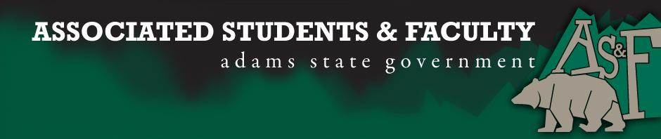

Adams State University Associated Students and Faculty Legislature
Bill Number: ASF1617036

Club Name: Psi Chi/ Psychology Club
Event Name or Trip Destination: Rocky Mountain Psychological Association Conference
Total Amount of AS&F Funding: $2500.
Total Club Points: 55
Author: AnnMarie Bennett
Sponsor: Chelsea Walljasper

Event or Trip Information
Who: Keren Bakker, AnnMarie Bennett, Ian Wingstrom, Savannah Smith, Rachel Ringler, Brittany Wilson, Chelsea Walljasper, Cole Maze, Marisa Juarez, Jocelyn Cabrera, Raul Madril, and Jerome Rodiguez
What: RMPA Conference
Where: Salt Lake City, Utah
When: April 6th-8th, 2016
Why: The club is hoping to obtain money to go to this annual Psychology conference. We went last year and had 6 people represent Adams State by presenting research that they had conducted.

Author Contact Information: AnnMarie Bennett; bennetta2@grizzlies.adams.edu; 310-869-1783

Account Information:

Additional Information: Psi Chi/Psychology has been very active over the years throughout campus and we are still doing our best to be active and engage with the community.

Assessment Rubric:
What do you want people attending the event, program, or going on the trip to gain from this experience? (Check/circle all that apply)

· Expanding the Learning Experience
· Analytical Reasoning
· Internal Self-Development
· Improving Teamwork and Leadership
· Community Service and Civic Engagement
· External Skill Development

Please define how your event, program, or trip will help people gain from this experience according to the goals you have checked.
The members of Psychology club’s learning experience will be expanded due to be able to watch other students and faculty members present on different topics. Also there are workshops that students attend that talk about engaging more with other people and using their psychological skills.
The conference will help with internal self-development due to members of the club learning how research can be presented and by possibly presenting themselves.

I, AnnMarie Bennett, present this bill for consideration of and approval by the Associated Students and Faculty Senate, this 7th day of November, 2016.

Implementation: Upon approval, be it enacted that:
- The proposed bill become adopted in favor of recognition by the AS&F Senate, and that:
- Psychology Club be funded $2,500

VOTE: Yeas_____ Nays______ Abs_______
Complete applicable sections:
- ADOPTED at ______________ meeting of the AS&F Senate on ___________.
- BILL did not pass at ______________ meeting of the AS&F Senate on ________.
- BILL will be reconsidered on ___________________.

Approved/Disapproved by AS&F President
_______________________________

