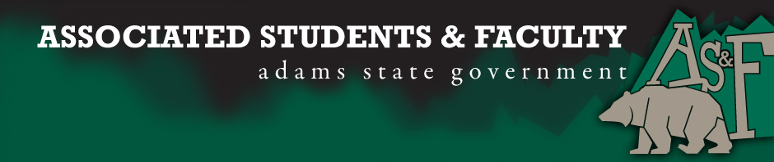
Adams State University Associated Students and Faculty Legislature
Bill Number: ASF1617035
Club Name: SACNAS
Event Name or Trip Destination: Networking
Total Amount of AS&F Funding: $210 for food.
Total Club Points: 60
Author: Stevie Schuster
Sponsor: Dr. Robert Kirk
Event or Trip Information
Who: Organization members and local professionals in science careers.
What: We are going to bring in local professionals in science careers (pharmacists, doctors, PA’s, scientists from BLM, DOW, etc.) so we can learn more about their careers and network with them.
Where: Adams State University
When: February 4, 2017
Why: Learn how to network with professionals in STEM careers.
Author Contact Information: Phone: 719-580-0152
Account Information: 8470 xxx 2520
Additional Information: This will be a fun experience! However, it will also be a learning experience for us science majors and we will be able to grow individually and as a club.
Assessment Rubric:
What do you want people attending the event, program, or going on the trip to gain from this experience? (Required for funding requests) (Check/circle all that apply)
· Expanding the Learning Experience
· Analytical Reasoning
· Internal Self-Development
· Improving Teamwork and Leadership
· Community Service and Civic Engagement
· External Skill Development

Please define how your event, program, or trip will help people gain from this experience according to the goals you have checked.
(Please define only the boxes checked)

It will help all of us gain all of the boxes checked because of networking, helping to improve ourselves, learning what do to after graduation, and reasoning with people with knowing how to handle scientist that are higher ranked.

I, Stevie Schuster, present this bill for consideration of and approval by the Associated Students and Faculty Senate, this 7th, day of November, 2016.
Implementation: Upon approval, be it enacted that:
- The proposed bill become adopted in favor of recognition by the AS&F Senate, and that:
- SACNAS be funded $210
VOTE: Yeas_____ Nays______ Abs_______
Complete applicable sections:
- ADOPTED at ______________ meeting of the AS&F Senate on ___________.
- BILL did not pass at ______________ meeting of the AS&F Senate on ________.
- BILL will be reconsidered on ___________________.
Approved/Disapproved by AS&F President
_______________________________

