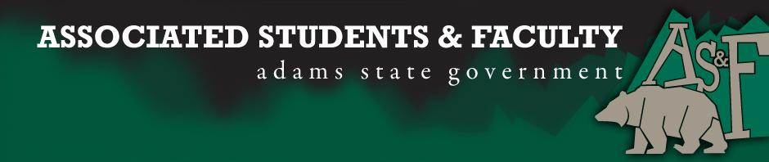

Adams State University Associated Students and Faculty Legislature
Bill Number: ASF1617032

Club Name: Art League
Event Name or Trip Destination: Italy
Total Amount of AS&F Funding: $6,000
Total Club Points: 65
Author: Nyla Zaidi
Sponsor: Julio Rodriguez

Event or Trip Information
Who: Art League members and the Art League Advisor Leslie Macklin
What: Experiencing the cultural and artistic treasures of Florence and Venice, and to go to the world’s largest art fair, The Venice Biennale
Where: Florence and Venice in Italy
When: May 15, 2017- May 26, 2017
Why: We want to be introduced to the rich heritage of Italian art and architecture of the cities, and to gain exposure to contemporary works of art at The Venice Biennale

Author Contact Information: Nyla Zaidi, zaidine@grizzlies.adams.edu

Account Information: 3200-835-7630-1900

Additional Information: We are aspiring to become better artists. We want to learn to appreciate the variety of different art mediums. We have been actively involved in the community through not only ASU sponsored volunteer projects but through our own community service projects. We helped to clean the San Luis Valley Museum, we helped and participated in the C.A.S.A fundraiser for HSI week, we are also working with the Sierra Grande Schools to provide free digital yearbooks to their students. We also are very active in doing our own club sponsored fundraising event, i.e. the Haunted House and we also work with Sodexo to run the concessions at various sporting events.

Assessment Rubric:
What do you want people attending the event, program, or going on the trip to gain from this experience? (Required for funding requests) (Check/circle all that apply)

· Expanding the Learning Experience: Through museums, the local art, and The Venice Biennale, art league members will be exposed to different mediums and techniques, that will expand their learning experience. Our members will also be exposed to the many different artistic cultures.
· Internal Self-Development: Exposure from seminars of artists and different art forms will give students help for self-development by learning about the different artists steps to success. At The Venice Biennale that we will be attending we will be given valuable advice, tips, and knowledge on how to better succeed at our art and how to further develop our skills.
· Improving Teamwork and Leadership: As we will be traveling and doing everything together we will greatly improve our club member’s teamwork amongst each other, and our leadership skills by learning how to effectively communicate and guide one another, which will help us to become better artists as we will be learning to properly and constructively critique one another’s work and to develop as well rounded artistic individuals.

Please define how your event, program, or trip will help people gain from this experience according to the goals you have checked.
(Please define only the boxes checked)

I, Nyla Zaidi, present this bill for consideration of and approval by the Associated Students and Faculty Senate, this 7th day of November, 2016.

Implementation: Upon approval, be it enacted that:
- The proposed bill become adopted in favor of recognition by the AS&F Senate, and that:
- Art League be funded $6,000
VOTE: Yeas_____ Nays______ Abs_______
Complete applicable sections:
- ADOPTED at ______________ meeting of the AS&F Senate on ___________.
- BILL did not pass at ______________ meeting of the AS&F Senate on ________.
- BILL will be reconsidered on ___________________.

Approved/Disapproved by AS&F President
_______________________________

