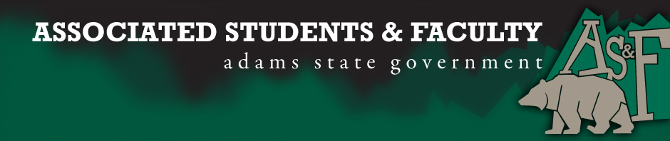
Adams State University Associated Students and Faculty Legislature
Bill Number: ASF1617031

Club Name: Latter-day Saint Student Association (LDSSA)
Event Name or Trip Destination: Formation of club
Total Amount of AS&F Funding: None
Total Club Points: None
Author: Tim Mobley
Sponsor: Megan Ray

Event or Trip Information

Who: The club will be open to all ASU students who wish to join
What: Formation of club
Where: ASU Campus
When: As soon as possible
Why: The purpose of the bill is have the Latter-day Saint Student Association (LDSSA) club become a formally recognized club on campus

Author Contact Information: Tim Mobley can be reached at 719-587-7646 or 719-298-6025 or by emailing timmobley@adams.edu

Account Information: An account has not been established yet

Additional Information: The club will provide spiritual education as well as service opportunities for students of the LDS (Mormon) faith as well as any other students who would like to join- regardless of religion.

Assessment Rubric: We expect those who attend LDSSA club to benefit by

- Expanding the Learning Experience
- Analytical Reasoning
- Internal Self-Development
- Improving Teamwork and Leadership
- Community Service and Civic Engagement
- External Skill Development

LDSSA proposes to expend the learning experience by incorporating spiritual knowledge along with the secular, academic knowledge. By gaining spiritual insights, the members will be able to develop their own internal self as they develop a closer relationship with God. To accomplish this goal, the club members will be invited to scripture study classes as well as opportunities to participate in various community service projects.

I, Tim Mobley, present this bill for consideration of and approval by the Associated Students and Faculty

Senate, this ___________ day of ____________________ , 2016.

Implementation: Upon approval, be it enacted that:
- The proposed bill become adopted in favor of recognition by the AS&F Senate, and that:
- Latter-day Saint Student Association be funded $0
Vote: Yeas_____ Nays ______ Abs _______
Complete application sections:

- ADOPTED at ________________ meeting of the AS&F Senate on _______________.

- BILL did not pass at ________________ meeting of the AS&F Senate on _________________.

- BILL will be reconsidered on ____________________________.

Approved / Disapproved by AS&F President

_________________________________

