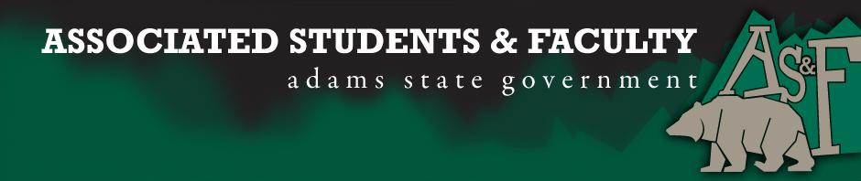

Adams State University Associated Students and Faculty Legislature
Bill Number: ASF1617028

Author: Aaron Davis
Sponsor: Sean Erice

Event or Trip Information
What: Bylaw change
Why: To better provide for the needs of clubs

Author Contact Information: davisaa@grizzlies.adams.edu

Account Information: NA

Additional Information (Platform): Upon feedback of the senate and clubs, I propose a change in the by laws that would affect the distribution of quarterly. Currently, the distribution of quarterly is divided equally amongst each of the four. Now, I would like to change the Bylaws so that the Senate can change the amount of funding for each quarterly by 15-30%. This leaves clubs with a little more flexibility in the amount of funding of quarterlies. Example: lesser requested quarterlies could be decided to have less money in the quarterly so that larger requested quarterlies can have more money to give away.

I, Aaron Davis, present this bill for consideration of and approval by the Associated Students and Faculty Senate, this 24th day of October, 2016.

Implementation: Upon approval, be it enacted that:
- The proposed bill become adopted in favor of recognition by the AS&F Senate, and that:
The bylaw change of quarterly distribution will immediately be taken into effect.

VOTE: Yeas_____ Nays______ Abs_______
Complete applicable sections:
- ADOPTED at ______________ meeting of the AS&F Senate on ___________.
- BILL did not pass at ______________ meeting of the AS&F Senate on ________.
- BILL will be reconsidered on ___________________.

Approved/Disapproved by AS&F President
_______________________________

