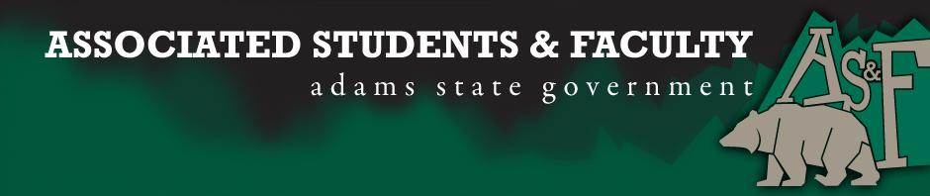

Adams State University Associated Students and Faculty Legislature
Bill Number: ASF1617025
Club Name: Nursing Senator
Event Name or Trip Destination: Senate Seat
Total Amount of AS&F Funding: NA
Total Club Points: NA
Author: Brenna Rivale
Sponsor: Sean Erice (HAPPSS Senator)

Event or Trip Information
Who: Julissa Rodriguez
What: Business Senator
Where: Adams State University
When: 2016-2017 Academic Year
Why: Involvement

Author Contact Information: rivaleb1@grizzlies.adams.edu

Account Information: NA

Additional Information (Platform:

My name is Julissa Rodriguez and I’m currently a freshman. I came to Adams State University because of the many opportunities this institution has to offer. I am currently a part of the C.A.M.P and SSS program; these programs help me be engaged with other students on campus. I would like to be a part of the AS&F because I want to get more involved in activities, school clubs, and community service. I feel like I would be able to communicate student thoughts to AS&F and and give students feedback on what goes around campus and AS&F. Moreover, I am also interested in making other students feel welcomed to Adams State and letting them know of the opportunities this university has to offer. I am very passionate with everything that has to do with the nursing program therefore I would like to be a senator for the nursing department. I truly believe that AS&F would be the perfect way for me to accomplish more involvement in school.

Assessment Rubric:
Role of a Senator
· Maintain a minimum 2.0 GPA
· Attend all AS&F Meetings
· Sponsor Legislation
· Author Legislation
· Voting power in all matters

I, Brenna Rivale, present this bill for consideration of and approval by the Associated Students and Faculty Senate, this 26th day of September, 2016.

Implementation: Upon approval, be it enacted that:
- The proposed bill become adopted in favor of recognition by the AS&F Senate, and that:
Julissa Rodriguez will immediately assume the responsibilities and duties of the office of Nursing Senator.

VOTE: Yeas_____ Nays______ Abs_______
Complete applicable sections:
- ADOPTED at ______________ meeting of the AS&F Senate on ___________.
- BILL did not pass at ______________ meeting of the AS&F Senate on ________.
- BILL will be reconsidered on ___________________.

Approved/Disapproved by AS&F President
_______________________________

