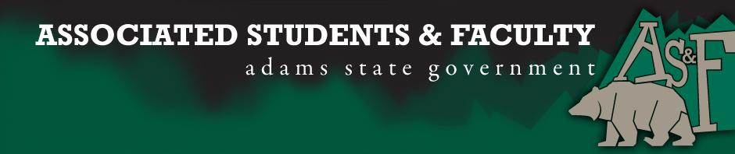

Adams State University Associated Students and Faculty Legislature
Bill Number: ASF1617020

Club Name: Adams State University - Phi Beta Lambda
Event Name or Trip Destination: National Fall Leadership Conference, Daytona Beach, FL
Total Amount of AS&F Funding: $4,999.40
Total Club Points: 70 Points
Author: Jessica Crowther
Sponsor: Cody Trujillo (Senator)

Event or Trip Information
Who: Our Executive Board, 3 other PBL Members, and Natalie Rogers, our advisor, will be attending. (Total: 8)
What: Attending a two day national leadership conference where students and advisors participate in motivational general sessions, professional development, and career planning workshops.
Where: Daytona Beach, FL (Hilton Daytona Beach Oceanfront Resort)
When: November 10-14, 2016
Why: We hope that at this conference we will learn how to increase: networking, leadership experience, competitive edge in events, and club recruitment to relay back to our entire club. We swept the Accounting events at State last year and had all 15 of our members qualify for nationals. When we went to nationals, none of us placed. Therefore, If we are able to attend this conference, the leadership team of our club will be better able to increase our competitive edge at nationals.

Author Contact Information:
Jessica Crowther: (719)- 849- 8172 crowtherjl1@grizzlies.adams.edu

Account Information: 3200-839-7630-1900

Additional Information: PBL is the largest collegiate business student organization in the world. It is an honor that Adams State is able to be apart of this organization.

Assessment Rubric:
What do you want people attending the event, program, or going on the trip to gain from this experience?

· X Expanding the Learning Experience
· Analytical Reasoning
· Internal Self-Development
· X Improving Teamwork and Leadership
· Community Service and Civic Engagement
· External Skill Development

Please define how your event, program, or trip will help people gain from this experience according to the goals you have checked.

Expanding the Learning Experience
Through the National Fall Leadership Conference members will learn many different skills and receive many different learning experiences that cannot be offered anywhere else. They will be able to relate the things that they are learning in their classes to the respective competitive events that they are competing in.

Improving Teamwork and Leadership
We will attend many different workshops and keynotes where we will learn different leaderships styles, practices, and tips that we can not only grow as a leader but we can bring back to the different clubs an organizations here on campus

I,Jessica Crowther, present this bill for consideration of and approval by the Associated Students and Faculty Senate, this 26 day of September, 2016.

Implementation: Upon approval, be it enacted that:
- The proposed bill become adopted in favor of recognition by the AS&F Senate, and that:
- PBL be funded $4999.40

VOTE: Yeas_____ Nays______ Abs_______
Complete applicable sections:
- ADOPTED at ______________ meeting of the AS&F Senate on ___________.
- BILL did not pass at ______________ meeting of the AS&F Senate on ________.
- BILL will be reconsidered on ___________________.

Approved/Disapproved by AS&F President
_______________________________

