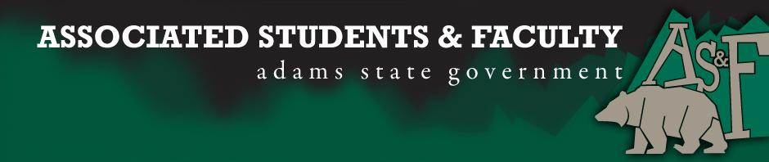

Adams State University Associated Students and Faculty Legislature
Bill Number: ASF1617018
Club Name: Pen and Inkwell: A Writer’s Guild
Event Name or Trip Destination: AWP 2017, Washington D.C.
Total Amount of AS&F Funding: $5,425.70
Total Club Points: 76
Author: Amie Chadwick
Sponsor: Jasmyn Brendle

Event or Trip Information
Who: Club Members
What: Traveling to the largest writing conference in North America
Where: Washington D.C., Washington Convention Center
When: February 4 – February 12, 2017
Why: With this bill, we hope to receive the funding to travel to this conference to better ourselves as not only writers, but also to enhance our networking skills and possibly ready ourselves with future employment.

Author Contact Information:
Amie Chadwick
penandinkwellwritersguild@gmail.com
chadwickar@grizzlies.adams.edu

Account Information:
3200-854-7630-1900

Additional Information:
This is the 50th anniversary of AWP, which gives us even more of an opportunity to network with other writers, get our work out into as many journals and presses as possible. We also would like to time to explore museums, such as the Smithsonian and the Newsuem, to further our minds as students and individuals.

Assessment Rubric:
What do you want people attending the event, program, or going on the trip to gain from this experience?

· Expanding the Learning Experience X
· Analytical Reasoning
· Internal Self-Development X
· Improving Teamwork and Leadership X
· Community Service and Civic Engagement
· External Skill Development X

Please define how your event, program, or trip will help people gain from this experience according to the goals you have checked.

Traveling to the AWP Conference for the second year in a row, will help us solidify our connections with the large writing community we established last year, as well as give us the opportunity to attract future students to ASU. This conference will help us network with future employers and develop better leadership and strengthen our networking connections with other universities and presses to get our names out into the community. We are also using this trip to broaden our horizons in terms of culture and history by visiting museums, art galleries, and shows.

I, Amie Chadwick, present this bill for consideration of and approval by the Associated Students and Faculty Senate, this 26th day of September, 2016.

Implementation: Upon approval, be it enacted that:
- The proposed bill become adopted in favor of recognition by the AS&F Senate, and that:
- Pen and Inkwell be funded $5425.70

VOTE: Yeas_____ Nays______ Abs_______
Complete applicable sections:
- ADOPTED at ______________ meeting of the AS&F Senate on ___________.
- BILL did not pass at ______________ meeting of the AS&F Senate on ________.
- BILL will be reconsidered on ___________________.

Approved/Disapproved by AS&F President
_______________________________

