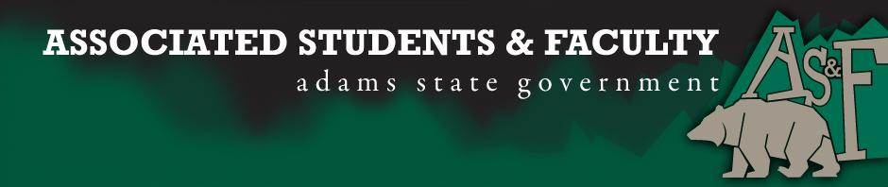

Adams State University Associated Students and Faculty Legislature
Bill Number: ASF1617016

Club Name: NAfME
Event Name or Trip Destination: CMEA
Total Amount of AS&F Funding: $6,079.08
Total Club Points: 79
Author: Andrew Naughton and Deanna Smith
Sponsor: Kevin Johnson

Event or Trip Information
Who: All organization members (22 registered) And one faculty member.
What: Attending the CMEA conference, education/music clinics, networking, etc…
Where: Colorado Springs, The Broadmoor.
When: January 25th-28th.
Why: To gain and expand our teaching strategies so that we may bring our experiences back and share with our Professors and peers at Adams State University.

Author Contact Information:
Andrew Naughton (719-393-3859)
Deanna Smith (719-229-6016)

Account Information: 320086076301900

Additional Information: All the music educators in the state will be there, as well as other collegiate NAfME chapters from various Colorado colleges. We will also be performing at the Broadmoor with the ASU band.

Assessment Rubric:
· Expanding the Learning Experience – Clinics we will be attending are made to further our understanding of music as well as provide professional development to equip us with the knowledge for our future in education.
· Analytical Reasoning – CMEA will further our understanding of the various theories of music and provide us new perspectives to bring back to ASU as well as our personal lives.

· Internal Self-Development – CMEA offers a variety of clinics that provide self-development opportunities. (Performance anxiety, rhythm, intonation, classroom management)
· Improving Teamwork and Leadership – Clinics such as “Leadership in School Music to Becoming a Professional Musician” and “Building a Strong Team From the Middle: An orchestra director’s guide.”
· Community Service and Civic Engagement – Education in general works to developing the combination of knowledge, skills, values and motivation to make that difference
· External Skill Development – Bringing the knowledge learned at CMEA back to share with our fellow NAfME chapters and other educators in the valley. It will also improve our skills as performers providing a better experience for our listeners (ASU).

I, Andrew Naughton and Deanna Smith, present this bill for consideration of and approval by the Associated Students and Faculty Senate, this 26th day of September, 2016.

Implementation: Upon approval, be it enacted that:
- The proposed bill become adopted in favor of recognition by the AS&F Senate, and that:
- NAfME be funded $6079.08

VOTE: Yeas_____ Nays______ Abs_______
Complete applicable sections:
- ADOPTED at ______________ meeting of the AS&F Senate on ___________.
- BILL did not pass at ______________ meeting of the AS&F Senate on ________.
- BILL will be reconsidered on ___________________.

Approved/Disapproved by AS&F President
_______________________________

