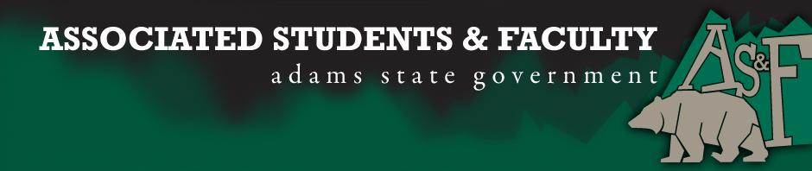

Adams State University Associated Students and Faculty Legislature
Bill Number: ASF1617014

Club Name: Bulls & Bears
Sponsor: Sean Erice
What: To be recognized as an official AS&F Club
Why: We want to create a community for the students of the Business Department to be part of Bulls & Bears.
Author Contact Information: gallegosa4@grizzlies.adams.edu
Additional Information: We would like to become a recognized AS&F club again. We are a small department that believes in the success of our students. We are looking to take a new approach to the club, and make it more successful then before.

I, (Angela Gallegos and Jakob Koons), present this bill for consideration of and approval by the Associated Students and Faculty Senate, this (22th) day of (September), 20 (16)
Implementation: Upon approval, be it enacted that:
- The proposed bill become adopted in favor of recognition by the AS&F Senate, and that:
- Bulls and Bears become an AS&F recognized club.

VOTE: Yeas_____ Nays______ Abs_______
Complete applicable sections:
- ADOPTED at ______________ meeting of the AS&F Senate on ___________.
- BILL did not pass at ______________ meeting of the AS&F Senate on ________.
- BILL will be reconsidered on ___________________.

Approved/Disapproved by AS&F President
_______________________________

