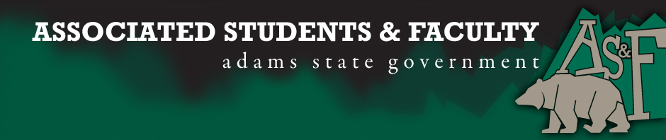
Adams State University Associated Students and Faculty Legislature
Bill Number: ASF1617013
Club Name: Rods and Rifles
Total Club Points: N/A
Author: Cameron King
Sponsor: Anthony Murray (Business Senator)

Event or Trip Information
What: To be a recognized as an official AS&F Club
Why: To help promote and inform students of the great outdoor opportunities in the SLV
Author Contact Information: kingcr@grizzlies.adams.edu
Additional Information: We would like to become a recognized AS&F club. Adams State has always had a very strong outdoors seeking student body and we would like to help to promote these students. The only type of outdoor opportunities that exist are adventure programs and we would like to bring back the great outdoors opportunities to the student body here at ASU. Hunting and fishing have always been a strong attractant to the valley and in the past the student body has had a strong advocate for these programs, over the years this tradition has disappeared and we are hoping to bring them back in a strong and supportive way. p

I, Cameron King, present this bill for consideration of and approval by the Associated Students and Faculty Senate, this 26th day of September, 2016.

Implementation: Upon approval, be it enacted that:
- The proposed bill become adopted in favor of recognition by the AS&F Senate, and that:
Rods and Rifles become an AS&F recognized club.

VOTE: Yeas_____ Nays______ Abs_______
Complete applicable sections:
- ADOPTED at ______________ meeting of the AS&F Senate on ___________.
- BILL did not pass at ______________ meeting of the AS&F Senate on ________.
- BILL will be reconsidered on ___________________.
Approved/Disapproved by AS&F President
_______________________________

