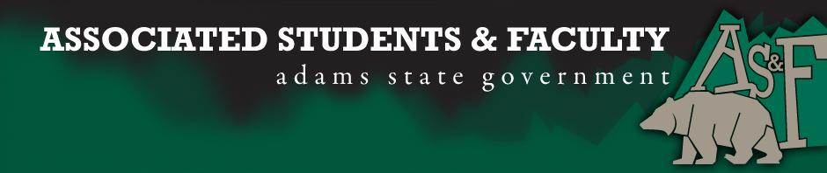

Adams State University Associated Students and Faculty Legislature
Bill Number: ASF1617012

Club Name: Psychology
Event Name or Trip Destination: Senate Seat
Total Amount of AS&F Funding: NA
Total Club Points: NA
Author: Patrick Cleary
Sponsor: Sean Erice (HAPPSS Senator)

Event or Trip Information
Who: Elken Edward Hecker
What: Psychology Senator
Where: Adams State University
When: 2016-2017 Academic Year
Why: Involvement

Author Contact Information: clearypj@grizzlies.adams.edu

Account Information: NA

Additional Information (Platform): My name is Elken Hecker, I am a second year psychology major and I am running for the position of Psychology Senator. I grew up in Rye, Colorado, and attended Rye High School. During my attendance at Rye High School, I participated in student council for three years: two as a vice president, and one as treasurer. Today I am on my second year working for the Adams State Police Department, where I register vehicles for proper parking. I originally came to Adams State for its great psychology program, and decided to stay for its amazing, diverse student body. I heard about AS&F through John Owsley by e-mail, and decided it would be a good way to get involved with, and help the student community. As for my personal life, I enjoy candles, puppies, and long walks on the beach during sunset.

Assessment Rubric:
Role of a Senator
· Maintain a minimum 2.0 GPA
· Attend all AS&F Meetings
· Sponsor Legislation
· Author Legislation
· Voting power in all matters

I, Patrick Cleary, present this bill for consideration of and approval by the Associated Students and Faculty Senate, this 12th day of September, 2016.

Implementation: Upon approval, be it enacted that:
- The proposed bill become adopted in favor of recognition by the AS&F Senate, and that:
Elken Edward Hecker will immediately assume the responsibilities and duties of the office of Psychology Senator.

VOTE: Yeas_____ Nays______ Abs_______
Complete applicable sections:
- ADOPTED at ______________ meeting of the AS&F Senate on ___________.
- BILL did not pass at ______________ meeting of the AS&F Senate on ________.
- BILL will be reconsidered on ___________________.

Approved/Disapproved by AS&F President
_______________________________

