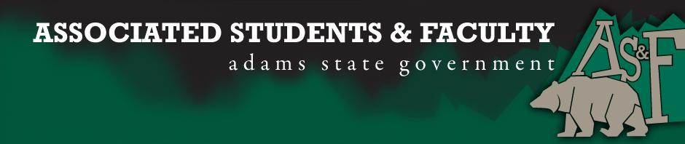

Adams State University Associated Students and Faculty Legislature
Bill Number: ASF1617010

Club Name: Biology & Earth Science
Event Name or Trip Destination: Senate Seat
Total Amount of AS&F Funding: NA
Total Club Points: NA
Author: Patrick Cleary
Sponsor: Sean Erice (HAPPSS Senator)

Event or Trip Information
Who: Julio Rodriguez
What: Biology & Earth Science Senator
Where: Adams State University
When: 2016-2017 Academic Year
Why: Involvement

Author Contact Information: clearypj@grizzlies.adams.edu

Account Information: NA

Additional Information (Platform): Hi my name is Julio Rodriguez. I’m a Sophomore here in Adams State University. I’m currently working towards my Bachelors in Cellular and Molecular Biology. The reason why I’m applying to become an AS&F Senator for the Biology department is because I love to work with students. I believe I’m the perfect fit for this position because throughout the year’s that I’ve been a student I’ve always been involved on campus. I like to get my friends and classmates involved whenever I’m doing any type of volunteer work or even if I’m just attending an event, for example last year for ASU Cares day I got 5 of my fellow classmates to join the team that I was going to volunteer with and even though they didn't really want to go I convinced them to go, at the end it was a success. I love getting other students involved, but it’s hard to get the word out to every single resident/student. But I’ve found another way that I believe is a great way to get students involved, Social Media. I currently run GrizzliesSnaps. This is a snapchat account where I post stories that students send in, I’ve noticed more engagement whenever an event is posted on there because with almost 700 student viewers we definitely get some of them to come out of their normal routine and attend events they normally wouldn’t. I believe that the AS&F Senator position would really help me, help more students get involved on campus.

Assessment Rubric:
Role of a Senator
· Maintain a minimum 2.0 GPA
· Attend all AS&F Meetings
· Sponsor Legislation
· Author Legislation
· Voting power in all matters

I, Patrick Cleary, present this bill for consideration of and approval by the Associated Students and Faculty Senate, this 12th day of September, 2016.

Implementation: Upon approval, be it enacted that:
- The proposed bill become adopted in favor of recognition by the AS&F Senate, and that:
Julio Rodriguez will immediately assume the responsibilities and duties of the office of Biology & Earth Science Senator.

VOTE: Yeas_____ Nays______ Abs_______
Complete applicable sections:
- ADOPTED at ______________ meeting of the AS&F Senate on ___________.
- BILL did not pass at ______________ meeting of the AS&F Senate on ________.
- BILL will be reconsidered on ___________________.

Approved/Disapproved by AS&F President
_______________________________

