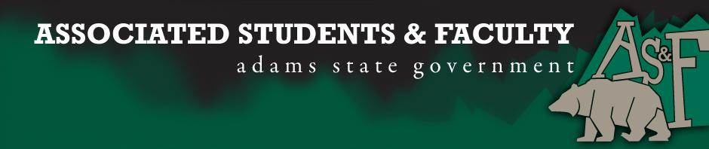

Adams State University Associated Students and Faculty Legislature
Bill Number: ASF1617006

Club Name: Business Senator
Event Name or Trip Destination: Senate Seat
Total Amount of AS&F Funding: NA
Total Club Points: NA
Author: Patrick Cleary
Sponsor: Sean Erice (HAPPSS Senator)

Event or Trip Information
Who: Anthony Murray
What: Business Senate Seat
Where: Adams State University
When: 2016-2017 Academic Year
Why: Involvement

Author Contact Information: clearypj@grizzlies.adams.edu

Account Information: NA

Additional Information (Platform): In the spring of 2015 I moved back to the San Luis Valley from Nebraska to once again resumed management at Riverbend Trout Farm for my family and now have taken the opportunity of being so close to Adams State University to complete my education at a University. When I first came to ASU I had no idea how active the students and faculty are to make the experience at Adams so unique and overall smooth for the other people around them. I would like the opportunity to extend my gratitude to them by continuing the same courtesy that I was brought into for others working and attending Adams State University. I know that I would be a good fit in AS&F from all of my experience from my past college as an RA and the other various boards that I served on during my education at Laramie County Community College. Also, even today I continue to serve boards in Colorado for aquaculture projects and practices. After being on these boards I have learned the importance in actively participating in the conversations that happen and allowing others to hear different and fresh opinions. Thank you for allowing me the opportunity to run for this position.

Assessment Rubric:
Role of a Senator
· Maintain a minimum 2.0 GPA
· Attend all AS&F Meetings
· Sponsor Legislation
· Author Legislation
· Voting power in all matters

I, Patrick Cleary, present this bill for consideration of and approval by the Associated Students and Faculty Senate, this 12th day of September, 2016.

Implementation: Upon approval, be it enacted that:
- The proposed bill become adopted in favor of recognition by the AS&F Senate, and that:
Anthony Murray will immediately assume the responsibilities and duties of the office of Business Senator.

VOTE: Yeas_____ Nays______ Abs_______
Complete applicable sections:
- ADOPTED at ______________ meeting of the AS&F Senate on ___________.
- BILL did not pass at ______________ meeting of the AS&F Senate on ________.
- BILL will be reconsidered on ___________________.

Approved/Disapproved by AS&F President
_______________________________

