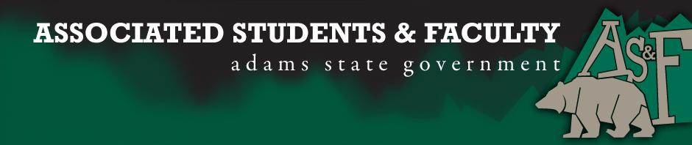

Adams State University Associated Students and Faculty Legislature
Bill Number: ASF1617003

Club Name: Music Senator
Event Name or Trip Destination: Senate Seat
Total Amount of AS&F Funding: NA
Total Club Points: NA
Author: Patrick Cleary
Sponsor: Sean Erice (HAPPSS Senator)

Event or Trip Information
Who: Alissa Morones
What: Music Senate Seat
Where: Adams State University
When: 2016-2017 Academic Year
Why: Involvement

Author Contact Information: clearypj@grizzlies.adams.edu

Account Information: NA

Additional Information (Platform): To be presented orally during the August 29, 2016 convening of the Associated Students & Faculty.

Assessment Rubric:
Role of a Senator
· Maintain a minimum 2.0 GPA
· Attend all AS&F Meetings
· Sponsor Legislation
· Author Legislation
· Voting power in all matters

I, Patrick Cleary, present this bill for consideration of and approval by the Associated Students and Faculty Senate, this 29th day of August, 2016.

Implementation: Upon approval, be it enacted that:
- The proposed bill become adopted in favor of recognition by the AS&F Senate, and that:
Alissa Morones will immediately assume the responsibilities and duties of the office of Music Senator.

VOTE: Yeas_____ Nays______ Abs_______
Complete applicable sections:
- ADOPTED at ______________ meeting of the AS&F Senate on ___________.
- BILL did not pass at ______________ meeting of the AS&F Senate on ________.
- BILL will be reconsidered on ___________________.

Approved/Disapproved by AS&F President
_______________________________

