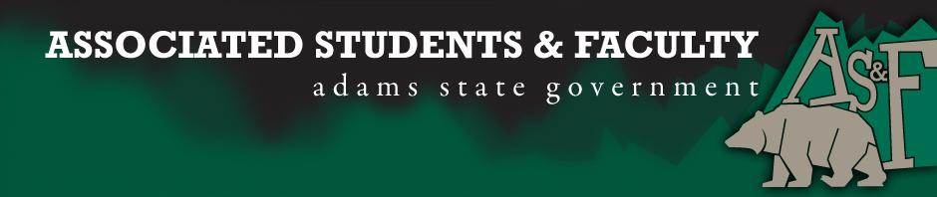

Adams State University Associated Students and Faculty Legislature
Bill Number: ASF1516041

Club Name: TriBeta Biology Club
Event Name or Trip Destination: Tri Beta Induction
Total Amount of AS&F Funding: $300.00
Total Club Points: 87
Author: Club Representative: Laura Heredia
Sponsor: Matthew Tulley

Event or Trip Information
Who: Members and Associates of TriBeta
What: 2016 Tri Beta Phi Eta Induction
Where: Alamosa, CO
When: April 28, 2016
Why: The Phi Eta Chapter inducts members annually to give students and faculty the opportunity to be nationally recognized as a member or associate of Tri Beta. The membership is lifetime.

Author Contact Information: heredialm@grizzlies.adams.edu

Account Information: 3200-856-7630-1900

Additional Information: There are GPA requirements to become a full member of Tri Beta. This induction includes a ceremony and a dinner.

Assessment Rubric:

· Expanding the Learning Experience √
· Analytical Reasoning
· Internal Self-Development √
· Improving Teamwork and Leadership √
· Community Service and Civic Engagement
· External Skill Development

Please define how your event, program, or trip will help people gain from this experience according to the goals you have checked.

Expanding the Learning Experience- Attendees will be able to learn more about Tri Beta. They will also get to network with professors in the department that they have not met or will get to know professors they already know on a better level. This networking will help all in attendance learn more about their field and the future.

Internal Self-Development- Individuals will be given the honor of carrying their membership. This will help fill the members’ resumes. Membership may also grant individuals openings in terms of future careers and/or research.

Improving Teamwork and Leadership- Students inducted as full members will be given the opportunity to become an officer of the local chapter. Members are expected to participate as a team to fundraise and engage in community service.

I, Laura Heredia, present this bill for consideration of and approval by the Associated Students and Faculty Senate, this 11th day of April, 2016.

Implementation: Upon approval, be it enacted that:
- The proposed bill become adopted in favor of recognition by the AS&F Senate, and that:
- Tri Beta be funded $300.00

VOTE: Yeas_____ Nays______ Abs_______
Complete applicable sections:
- ADOPTED at ______________ meeting of the AS&F Senate on ___________.
- BILL did not pass at ______________ meeting of the AS&F Senate on ________.
- BILL will be reconsidered on ___________________.

Approved/Disapproved by AS&F President
_______________________________

