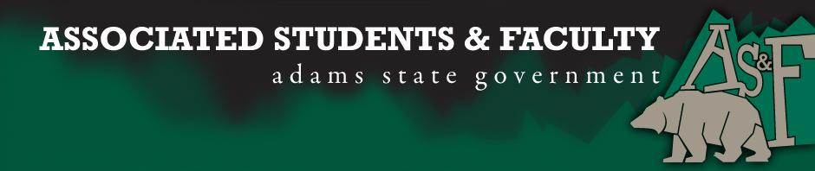

Adams State University Associated Students and Faculty Legislature
Bill Number: ASF1516040

Club Name: Tri Beta
Event Name or Trip Destination: Tri Beta Regional Conference
Total Amount of AS&F Funding: $884.11
Total Club Points: 70+
Author: Laura Heredia (Club Representative)
Sponsor: Matthew Tulley

Event or Trip Information
Who: Tri Beta National Biological Honor Society
What: Annual Conference
Where: Adams State University, Alamosa
When: April 15th and 16th, 2016
Why: Each year a chapter from Tri Beta volunteers to host the conference. This year Phi Eta (Adams State University) has been given the privilege to host the conference.

Author Contact Information: heredialm@grizzlies.adams.edu

Account Information: 3200-856-7630-1900

Additional Information: Phi Eta has been recognized as a chapter of Tri Beta since 1991. This regional conference includes dinners, keynote speakers, a show at the planetarium, poster presentations, oral presentations, activities, and an awards ceremony.

Assessment Rubric:

· Expanding the Learning Experience √
· Analytical Reasoning √
· Internal Self-Development √
· Improving Teamwork and Leadership √
· Community Service and Civic Engagement
· External Skill Development √

Expanding the Learning Experience- Attendees will get the opportunity to see research being done by a variety of people. They will be able to experience visual and audio presentations. The information will be coming from undergraduate students, graduate students, professors, and other well respected members of the Tri Beta society.

Analytical Reasoning- Everyone in attendance will be able to see how others have used analytical reasoning in their work. They will be given the chance to communicate with others that they can relate to. This communication will include questions and answers that will improve analytical thinking.

Internal Self-Development- Individuals will be given information on possible future research they might conduct. They will also be exposed to new areas of science that may spark a new lifelong interest or build on interests that have already been established. Some ASU students will be privileged in presenting their own research.

Improving Teamwork and Leadership- Students and faculty will be able to network with other teams and leaders. Work that has been completed by a more than a single person will reflect the teamwork that is necessary to accomplish a common set of goals. This opportunity will help us network and discover new means of teamwork and leadership.

External Skill Development- Hearing and seeing presentations will promote skill development for presenting research. Attendees will be able to absorb new and perhaps better ways to present information. Organization and time management will be implied during this event in order to gain the maximum amount of benefits available.

I, Laura Heredia, present this bill for consideration of and approval by the Associated Students and Faculty Senate, this 11th day of April, 2016.

Implementation: Upon approval, be it enacted that:
- The proposed bill become adopted in favor of recognition by the AS&F Senate, and that:
- Tri Beta be funded $884.11

VOTE: Yeas_____ Nays______ Abs_______
Complete applicable sections:
- ADOPTED at ______________ meeting of the AS&F Senate on ___________.
- BILL did not pass at ______________ meeting of the AS&F Senate on ________.
- BILL will be reconsidered on ___________________.

Approved/Disapproved by AS&F President
_______________________________

