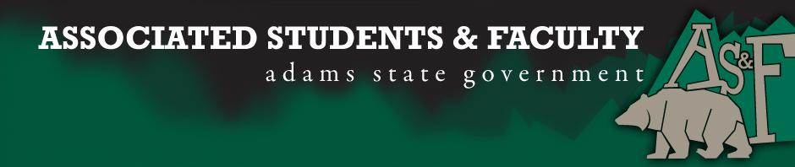

Adams State University Associated Students and Faculty Legislature
Bill Number: ASF1516032

Club Name: Psi Chi/ Psychology Club
Event Name or Trip Destination: Denver, CO. Rocky Mountain Psychological Association (RMPA)
Total Amount of AS&F Funding: $2,987.25
Total Club Points: 87 points
Author: Nicholas Spencer
Sponsor: Matthew Tulley (GAB Senator)

Event or Trip Information
Who: Nicholas Spencer, Kelsie Baggs, Will Mims, Ian Wingstrom, Raul Madril, Danielle Walters, Annalore Trujillo, Ann Marie Bennett, Tara Grebert, Elizabeth Marino, Oona King, Brandon Coffey, Jocelyn Cabrera, Keren Bakke, Jerome Rodriguez, Demi Mizokami, Hannah Ramadillia, Kyle Darling, Monica Brown, Chelsea Henderson, Matthew Tulley.

What: RMPA is the regional conference for the southwest. It is a rare opportunity for psychology students to see firsthand research from psychological giants and participate in hands-on experience with seminars, workshops, and lectures.

Where: The 2016 Rocky Mountain Psychological Association Convention will take place in Denver, Colorado at the Renaissance Hotel Denver.

When: April 14-16, 2016

Why: As an organization, our goal is to inspire Adams State students to begin a career in lifelong learning. We want to spark our students interest sparked to strive for higher education. Students who develop more educational pursuits and follow through, will be a greater help to our campus community, local community, and themselves.

This RMPA, our club will be introducing many freshman students to the atmosphere of conferences, but we are there to present research. Eight members of our department will be presenting original research. Poster and oral presentations the foundation of demonstrating research to the larger community. We will shine a bright light on Adams State University and hopefully improve registration rates as well as retention rates. Presenting our potential for promising careers will attract students and faculty to assimilate to our culture.

Attending RMPA will help students connect ideas and improve comprehension of psychological topics. Seeing first-hand research we study in class will increase interest and productivity throughout their careers. The chance to meet psychologists who publish landmark research helps students make the connection that famed psychologists were once undergrad students too.

With 21 students hoping to attend RMPA, there are multiple opportunities for leadership development. We will have students stepping up and encouraging participation. Before and after RMPA, we will hold professional seminars for members and students campus-wide. This event will demonstrate the types of behaviors, dress, and professionalism required for academia related events. Learning and teaching good habits will create a tradition in our department and connect with other departments on campus. Opportunities such as visiting RMPA are fundamental to student growth. Students will be able to identify with their future careers and solidify who they hope to become after graduation.

Author Contact Information: (719)494-5610 spencernb@grizzlies.adams.edu

Account Information: 3200-840-7630-1900

Additional Information: As an organization, we are very active on campus. We were at all the homecoming events with enthusiasm and excitement. We have also been at both club fairs this school year recruiting and connecting students with major-appropriate clubs. In addition to campus activities, we have volunteered in the community in association with ASU Cares, and Kaboom. We recently finished our annual Butterbraids fundraiser and look forward to our second annual Holiday Platters fundraiser this winter. We are in the process of bringing a distinguished psychologist to campus and providing a lecture

Assessment Rubric:
What do you want people attending the event, program, or going on the trip to gain from this experience? (Required for funding requests) (Check/circle all that apply)

- Expanding the Learning Experience
  - Attending and making connections with students and professors from the entire southwest region.
- Analytical Reasoning
  - Using concepts and ideologies to understand to expand on objective topics.
- Internal Self-Development
  - Identifying with other students and professors to develop a sense of identity and their potential future.
- Improving Teamwork and Leadership
  - Aside from workshops and seminars, assigning roles and responsibilities to maintain accountability for each student attending RMPA.
- Community Service and Civic Engagement
- External Skill Development
  - Hands on experience with networking, critical thinking, resume building, applying for higher education, and teamwork.

I, Nicholas Spencer, present this bill for consideration of and approval by the Associated Students and Faculty Senate, this 11th day of April, 2016.

Implementation: Upon approval, be it enacted that:
- The proposed bill become adopted in favor of recognition by the AS&F Senate, and that:
- Psychology Club be funded $2,987.25

VOTE: Yeas_____ Nays______ Abs_______
Complete applicable sections:
- ADOPTED at ______________ meeting of the AS&F Senate on ___________.
- BILL did not pass at ______________ meeting of the AS&F Senate on ________.
- BILL will be reconsidered on ___________________.

Approved/Disapproved by AS&F President
_______________________________

