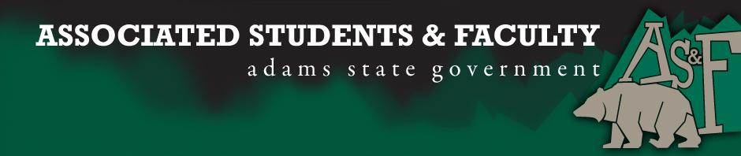

Adams State University Associated Students and Faculty Legislature
Bill Number: ASF1516043

Club Name: Greek Life Interest Group
Event Name or Trip Destination: Greek Life Kick Off
Total Amount of AS&F Funding: $500
Total Club Points: 0
Author: AnnMarie Bennett
Sponsor: Matthew Tulley

Event or Trip Information
Who: Greek Life Interest Group
What: Hosting a finals event and getting ready for the start of next year
Where: The event will take place in the Student Life Center and on Campus Green
When: August 29th, August 30th, August 31st, September 1st, and September 10th
Why: We are hoping to not only spread the word of the group, but to also let the ASU community know that the Greek Life being on campus is not a bad thing. The group is also hoping to be prepared for the start of next year.

Author Contact Information: E-mail: bennetta2@grizzlies.adams.edu
Phone: 310-869-1783

Account Information: N/A

Additional Information: This is a relatively new group, but we understand that people are concerned about hazing and alcohol abuse. To solve that we have made it a part of the Fraternity, Sorority, and Greek Life Constitution.(What other information do you want voters to know about yourself, your event, or your trip?)

Assessment Rubric:

· Expanding the Learning Experience
Our event will help expand the learning experience because it is a event where people can not only study but can also get help from other people that they would not normally socialize with.
· Community Service and Civic Engagement
This event will be open not only to people who belong to the sorority or fraternity, but people who a part of the ASU community and anyone else who would like to come

I, AnnMarie Bennett, present this bill for consideration of $500 and approval by the Associated Students and Faculty Senate, this Monday the 11th day of April, 2016.

Implementation: Upon approval, be it enacted that:
- The proposed bill become adopted in favor of recognition by the AS&F Senate, and that:
- Greek Life Interest Group be funded $500

VOTE: Yeas_____ Nays______ Abs_______
Complete applicable sections:
- ADOPTED at ______________ meeting of the AS&F Senate on ___________.
- BILL did not pass at ______________ meeting of the AS&F Senate on ________.
- BILL will be reconsidered on ___________________.

Approved/Disapproved by AS&F President
_______________________________

