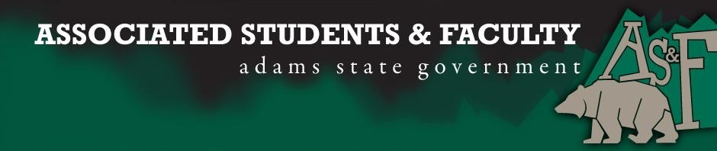

Adams State University Associated Students and Faculty Legislature
Bill Number: ASF1516039

Club Name: Art League
Event Name or Trip Destination: Denver, CO
Total Amount of AS&F Funding: $3757
Total Club Points: 84
Author: Amanda Bushere
Sponsor: John Owsley

Event or Trip Information
Who: Art League members
What: Denver Museums and Comic-Con
Where: Downtown Denver. Denver, CO
When: June 12, 2016- June 20, 2016
Why: To experience the art community in Denver and the differences in the art culture. We would be able to bring back different views of the various artists and to be able to create art based on what we see. We will be promoting Adams State University by wearing our ASU Art League t-shirts.

Author Contact Information: Amanda Bushere (303) 513-6722

Account Information: 3200-835-7630-1900

Additional Information: We are aspiring to become better artists. We want to learn to appreciate the variety of different art mediums. We have been actively involved in the community through not only ASU sponsored volunteer projects but we helped build a playground for children in the community, we helped with the C.A.S.A Fashion Show, C.A.S.A high school student volunteer project.

Assessment Rubric:
What do you want people attending the event, program, or going on the trip to gain from this experience? (Required for funding requests) (Check/circle all that apply)

· Expanding the Learning Experience: Through museums, the local art, and comic con convention, art league member will be exposed to different mediums and techniques, that will expand their learning experience. Our art league member will be exposed to the many different artistic cultures.
· Analytical Reasoning
· Internal Self-Development: Exposure from seminars of artists and different art forms will give students help for self-development by learning the speakers steps to success. In the speeches at the seminars that we will be attending at Comic Con we will be given valuable advice and tips on how to better succeed at our art and how to further develop our skills.
· Improving Teamwork and Leadership: we want to create a scavenger hunt for the Denver Art Museum that would keep them actively engaged in the Denver Art Museum. This would improve team working skills by putting our art league members in pairs to seek out the clues for a currently undetermined reward. The teams would have to pay close attention to the various art pieces to see if they can determine the clues from any particular art work in the museum.
· Community Service and Civic Engagement
· External Skill Development

Please define how your event, program, or trip will help people gain from this experience according to the goals you have checked.

I, Amanda Bushere, present this bill for consideration of and approval by the Associated Students and Faculty Senate, this 11th day of April, 2016.

Implementation: Upon approval, be it enacted that:
- The proposed bill become adopted in favor of recognition by the AS&F Senate, and that:
- (Art League) be funded ($3757.00)

VOTE: Yeas_____ Nays______ Abs_______
Complete applicable sections:
- ADOPTED at ______________ meeting of the AS&F Senate on ___________.
- BILL did not pass at ______________ meeting of the AS&F Senate on ________.
- BILL will be reconsidered on ___________________.

Approved/Disapproved by AS&F President
_______________________________

