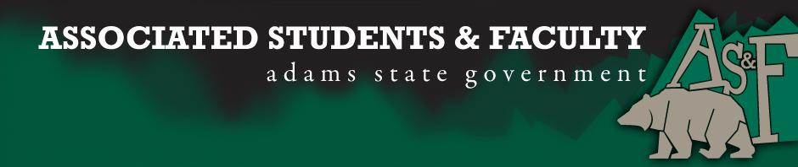

Adams State University Associated Students and Faculty Legislature
Bill Number: ASF1516037

Club Name: Adams State Improv Troupe (not an AS&F club)
Event Name or Trip Destination: Second City Chicago, Illinois
Total Amount of AS&F Funding: $6,964.15
Total Club Points: NA
Author: Taylor Trujillo
Sponsor: Laruen Trujillo (ETC Senator)

Event or Trip Information
Who: The Adams State Improv Troupe (10 members) and Professor Jenna Neilsen are planning to attend Improvisation training courses at the Second City Improv Company, while representing ASU and the Adams State Theatre Department on a world renowned Improv stage.

What: A week long master class in Chicago with the Second City Improv Company

Where: Second City Chicago Illinois

When: March 19, 2016 through March 27, 2016

Why: We hope to gain the last of the funding that we need to travel to Chicago to learn from the master teachers at Second City. The rest of the funding has been secured through department funding and performance fundraising. (40% of total travel is $6,514.64. However, the Troupe has secured more than 60% (75% in fact) of our total funding and are thus only asking for that which we need to make up the difference. (Approx. 24.5%)

Author Contact Information: trujillotm1@grizzlies.adams.edu

Account Information: 100-322-7332-1600

Additional Information: We are the Adams State University Improv Troupe. We perform multiple shows a year for Adams State Students, Faculty, and the local community (16 total performances during the 2014-2015 school year to serve as a point of reference). A week long training seminar in Chicago with the Second City Improv Troupe is a great opportunity for Adams State University Theater Majors. Ten Theater majors will be traveling to Chicago, to train with and observe the world renowned Second City Improv Troupe. This will be the second time that Professor Jenna Neilsen has taken a group of Theater Majors to study at the Second City. At this week long seminar students will study the latest Improv techniques from professional that perform on a world renowned stage.

Assessment Rubric:
What do you want people attending the event, program, or going on the trip to gain from this experience? (Required for funding requests) (Check/circle all that apply)

· Expanding the Learning Experience X
· Analytical Reasoning
· Internal Self-Development X
· Improving Teamwork and Leadership X
· Community Service and Civic Engagement X
· External Skill Development X

.
The group of students traveling will have the opportunity to improve their craft and bring back what they have learned to the local campus community. They will learn ways to improve public speaking through the art of improvisation. The training at the Second City not only helps the students attending but Professor Neilsen also has the opportunity to add to her repertoire of teaching skills. Advancing Adams States Improv technique not only helps theater majors but it also helps students of all majors overcome a fear of public speaking, improve upon communication skills, and reach a group mind consensus that helps all people work together as one. Improv is a great way for groups and organizations to learn to work together as an ensemble that helps promote unity across all spectrums of academic learning. Improv has also spread outside of the Theater Department to positively affect campus such as helping with homecoming. Professor Neilsen helps clubs by giving a lecture on how to make great skits for the homecoming Medicine Show. In fact two Improv students wrote the 2nd place winning skit for the 2015 Medicine Show. They also perform for different Adams State Functions. In the last year they have performed (beyond their late night performances in the Xperimental Theatre) for The Evening with Our Stars alumni event, at Dr. Svaldi’s retirement dinner, for Women’s Day, in collaboration with the counseling center, as part of the ASU Equality: Standing Strong Project, and for an after prom at Del Norte high school. Improv is a great way for all of Adams State University Students to break out of their comfort zone and gain important life skills.

I, Taylor Trujillo, present this bill for consideration of and approval by the Associated Students and Faculty Senate, this 15 day of February, 2016

Implementation: Upon approval, be it enacted that:
- The proposed bill become adopted in favor of recognition by the AS&F Senate, and that:
- Adams State Improv Troupe be funded $6,964.15

VOTE: Yeas_____ Nays______ Abs_______
Complete applicable sections:
- ADOPTED at ______________ meeting of the AS&F Senate on ___________.
- BILL did not pass at ______________ meeting of the AS&F Senate on ________.
- BILL will be reconsidered on ___________________.

Approved/Disapproved by AS&F President
_______________________________

