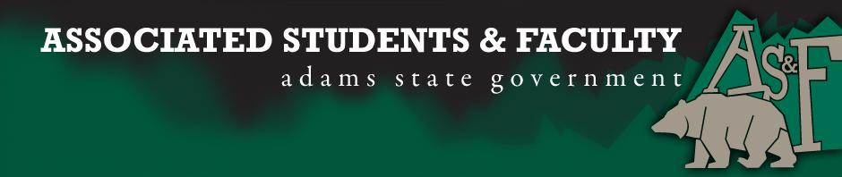

Adams State University Associated Students and Faculty Legislature
Bill Number: ASF1516036

Club Name: Newman Grizz Catholic
Event Name or Trip Destination: Alternative Break Experience 2016 – Sonora, Mexico
Total Amount of AS&F Funding $5,217.32
Total Club Points: 47
Author: Adrian Reyes
Sponsor: Gloria Quintana (Non-Traditional Senator)

Event or Trip Information
Who: Any ASU student may apply and will gladly be considered. ASB does not discriminate with regard to gender, sexual orientation, race or belief. ASB has always included students outside of Newman as well community members whose nonprofit work within the Alamosa community would be enhanced by participation in ASB (only one community member per year). Most often, this has been a La Puente staff member. The Newman advisor accompanies the group.
What: **See attached itinerary.
Where: Sonoran desert of Mexico with visits to the communities of Naco, Magdalena de Kino, Bahia de Kino, and Guaymas. The primary destination is Bahia de Kino where we have local community contacts. Travel is by road.
When: Saturday, March 19 through Sunday, March 27
Why: Alternative Break (ASB) is a short-term cultural immersion to experience another culture, promote a spirit of service and learn about social justice. ASB exemplifies the mission of ASU to “educate, serve and inspire our diverse populations in pursuit of their lifelong dreams and ambitions” by providing students a memorable experience that can prepare them to more easily integrate into a diverse campus and global community. ASB promotes intellectual, social and spiritual growth; it prompts participants to reflect critically upon their role as citizens. ASB encourages bridge-building and interconnection in a world where differences too often lead to distrust and division. The ASB experience integrates a number of academic disciplines, with scheduled time for reflection and discussion that assist with retention of ideas and insights.

The funding being requested of AS&F will make it possible to travel as “goodwill ambassadors” inspired to see the inherent dignity within each person and to approach each place we visit as Holy Ground. (What’s your why? What do you hope to accomplish with this bill?) (Required)

Author Contact Information: reyesa2@adams.grizzlies.edu or adrian27re@yahoo.com
(720) 409-6192(Required)

Account Information: 3200-857-7630-1900
Additional Information:
- There will be various opportunities to engage within local communities including sight-seeing, community dinners, open forums with community leaders, etc.
- Familias Unidas – A host site similar to Habitat for Humanity that empowers families to self-help and involves the local community and supporters. http://omekumene.blogspot.com/2012/03/familias-unidas-bahia-kino.html
- ASB participants will work alongside a Familias Unidas family to paint their house.
- We will take a side trip to Guaymas to visit Casa Franciscana.
- Semana Santa, or Holy Week will be an additional spiritual and cultural aspect of this year’s experience. It is also spring break for Mexican schools.l
- Commitment of ASB participants - ASB participants commit a significant amount of personal time beyond the immersion week itself. (3 pre-and 1 post-ASB meetings). ASB is purely voluntary – not connected to or required by any class and reflects the altruistic motivations of its participants.

Assessment Rubric:
What do you want people attending the event, program, or going on the trip to gain from this experience? (Required for funding requests) (Check/circle all that apply)

· Expanding the Learning Experience X
· Analytical Reasoning X
· Internal Self-Development XXX
· Improving Teamwork and Leadership XX
· Community Service and Civic Engagement XXX
· External Skill Development X

Please define how your event, program, or trip will help people gain from this experience according to the goals you have checked.

Expanding the Learning Experience – Participants will gain a sense of context, taking abstract concepts from the classroom, media, etc., with regard to border issues, immigration, Mexican culture, etc. and comparing them with their own experiences. Majors such as nursing, sociology, history, business, art, etc, can be enhanced through this type of direct contact.
Analytical Reasoning - Discussions might address structural systems of inequality, injustice, oppression and marginalization including social movements that have developed and their effectiveness.
Internal Self-Development –Keeping a field journal and doing without electronic devices promotes introspection. Participants confront their own fears about meeting new people, eating different food, etc. Culture shock is real and at some point, participants must confront their own fears, anxieties, and biases.
Improving Teamwork and Leadership - The group travel aspect is often the most challenging piece of ASB. ASB challenges participants to interact closely with one another, mediate differences, relieve tensions, pull together, listen and offer constructive feedback, and live outside their comfort zone. Participants alternate leading group reflections, which develops facilitation skills. There is a student leader for ASB who coordinates many aspects of travel and who communicates with hosts.
Community Service and Civic Engagement – Participants learn about the difference between direct service, or meeting basic needs, and social justice – confronting structural issues. Participants are encouraged to appreciate the difference between “helping” and “serving.” Sometimes our “help” actually hinders. We have learned that the best way to serve is to simply experience the culture and then share what we’ve experienced with others.
External Skill Development – Participants can practice another language, do public speaking (taking turns introducing the group at host sites), learn to cook a local dish, paint a house, convert foreign currency, etc.
-
(Please define only the boxes checked)

I, Adrian Reyes, present this bill for consideration of and approval by the Associated Students and Faculty Senate, this 15th day of February 2016

Implementation: Upon approval, be it enacted that:
- The proposed bill become adopted in favor of recognition by the AS&F Senate, and that:
- Newman Grizz Catholic be funded $5,217.32.

VOTE: Yeas_____ Nays______ Abs_______
Complete applicable sections:
- ADOPTED at ______________ meeting of the AS&F Senate on ___________.
- BILL did not pass at ______________ meeting of the AS&F Senate on ________.
- BILL will be reconsidered on ___________________.

Approved/Disapproved by AS&F President
_______________________________

