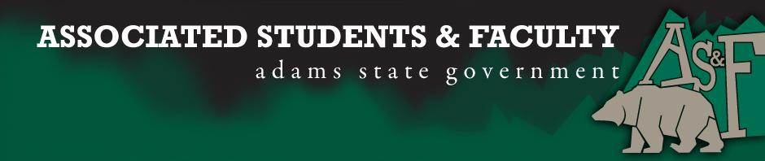

Adams State University Associated Students and Faculty Legislature
Bill Number: ASF1516034

Club Name: ACDA
Event Name or Trip Destination: Opera Colorado
Total Amount of AS&F Funding: $930.00
Total Club Points: 62
Author: Leeanne Roath (Music Senator)
Sponsor: Skyler Choice (ACDA Representative)

Event or Trip Information
Who: All students, faculty, and community members are allowed entry to the Opera Colorado performance free of charge.
What: Two reduced opera performances from Opera Colorado and a Master Class for auditioned Vocal Studio students.
Where: Richardson Auditorium
When: March 16-17
Why: Opera Colorado is an incredible program that has performed for ASU the past several years. They offer unmatched expertise for aspiring college and high school musicians. The night of entertainment will bring the public and students an amazing experience. The Master Class will improve the abilities of Vocal students, which enhances the Adams State title in competition, to future employers, graduate schools, and prospective students. This also provides a great recruitment opportunity for anyone looking at attending.

Author Contact Information: 719-468-3037

Account Information: 3200-872-7630-1900

Additional Information: Our main focus with Opera Colorado is to bring fun into classic opera stories. Opera Colorado performs cuttings of opera material and adds a very modern twist with costuming, props and language. It’s a truly enjoyable experience for all ages and all walks of life.

Assessment Rubric:
What do you want people attending the event, program, or going on the trip to gain from this experience? (Required for funding requests) (Check/circle all that apply)

· Expanding the Learning Experience X
· Analytical Reasoning
· Internal Self-Development X
· Improving Teamwork and Leadership X
· Community Service and Civic Engagement X
· External Skill Development X

Please define how your event, program, or trip will help people gain from this experience according to the goals you have checked.

This event will expand the learning experience by bringing entertaining art and the histories and information surrounding it to the San Luis Valley, students, and faculty of ASU. Opera Colorado aids with internal self-development using timeless opera stories to enrich culture and the lives of those attending. These classics provoke thought, whether it be about the pursuing of dreams or a cautionary tale. The teamwork and leadership of the ASU Vocal studio will be greatly enhanced by the work it takes to organize and set up the event, as well as the application of the Q&A, and the Master Class for our own opera production this year. Having Opera Colorado perform here will give a wonderful night of music to our community that is already very involved in the Arts and the events on ASU campus. This event will encourage more attendance to future events of all nature. For the members of ACDA and Vocal Studio, their external skills will be enriched directly through the master class, and indirectly through the performance. By watching and studying the details visually, technique-wise, and vocally- the students will be improving greatly.

I, Leeanne Roath, present this bill for consideration of and approval by the Associated Students and Faculty Senate, this 15th day of February, 2016.

Implementation: Upon approval, be it enacted that:
- The proposed bill become adopted in favor of recognition by the AS&F Senate, and that:
- ACDA be funded $930.00

VOTE: Yeas_____ Nays______ Abs_______
Complete applicable sections:
- ADOPTED at ______________ meeting of the AS&F Senate on ___________.
- BILL did not pass at ______________ meeting of the AS&F Senate on ________.
- BILL will be reconsidered on ___________________.

Approved/Disapproved by AS&F President
_______________________________

